**Cutting Edge:**

**From Surgeon’s Scrubs to Startup Success**

**CONTENTS**

|  | **PAGES** |
| --- | --- |
| **ABSTRACT** |  |
| **CHAPTER 1 -INTRODUCTION TO INNOVATION** |  |
| * Definition of Innovation * Invention vs. Innovation vs Innovativeness: Understanding the Difference * About Innovativeness * History and Evolution of Innovation * Intellectual Property (IP) * Role & Importance of IP |  |
| **CHAPTER 2- THE FOUNDATION OF INNOVATION**   * Theories of Innovation * Types of Innovation * Why and How Innovation Matters? * Importance of Changing Fixed to Growing Mindset |  |
| **CHAPTER 3 - THE PROCESS: RESEACH**   * Specialties in Diabetic Foot Ulcers * The Healthcare Revolution - AI & VR   **CHAPTER 4- OUT OF THE LAB: COMMERCIALIZING INNOVATIONS**   * Challenges with current Prosthetics * Concept to Designs * Application process * Prototyping & Testings * Iteration and Feedback Loops: Refining and Evolving Concepts * Beyond Prosthetics: Expanding Innovation into Orthopaedics, Wound Care, VR surgeries training, Ankle fixation devices * Awards & Achievements |  |
| Launching to Market: The Startup Journey and Scaling   * Market Research * Business Model Range, Dilemma, Cost, Issue and challenges * Licensing Business Model * Product and Marketing planning * Strategies and Growth of business |  |
| **CHAPTER 5- GOOD TO GREAT: LESSONS FROM THE JOURNEY**   * The Spirit of the innovator * Overcoming Organizational Resistance to Change * Financial Constraints and Securing Funding for Innovation * Navigating Legal and Regulatory Hurdles * Risk-Taking and Managing Failure in Innovation |  |
| **CHAPTER 6 - THE JOURNEY OF CHANGE: ZERO TO ON**E   * Innovation as a Lifelong Journey * Becoming an Innovator: A Personal Path Forward * Continuous Learning: The Key to Evolving as an Innovator * A Call to Action |  |
| **CONCLUSION** |  |
| **ACKNOWLEDGEMENTS** |  |
| **REFERENCES** |  |
| **INDEXS** |  |
| **BIOGRAPHY** |  |
| **LAMPIRAN** |  |
|  |  |
|  |  |

**ABSTRACT**

"**Cutting Edge: From Surgeon’s Scrubs to Startup Success**" offers a profound exploration of the intersection between healthcare innovation and entrepreneurship, driven by the urgent need to address one of the most pressing global health challenges: diabetes mellitus. As one of the most serious global health issues, diabetes places an immense burden on public health systems and socioeconomic development worldwide.Malaysia has the highest rate of diabetes in Western Pacific region and one of the highest in the world, costing around 600 million US dollars per year. (Ganasegeran et.al, 2020). According to The Star, The prevalence of diabetes raised from 11.2% in 2011 to 18.3% in 2019, with a 68.3% increase.

According to a National survey report, in Malaysia in 2019, 3.6 million adults (18 and above years) had diabetes, 49% (3.7 million) cases were undiagnosed.Diabetes is expected to affect 7 million Malaysian adults aged 18 and older by 2025, posing a major public health risk with a diabetes prevalence of 31.3%. (Institute for Public Health (IPH), National Institutes of Health, Ministry of Health Malaysia. 2020. National Health and Morbidity Survey (NHMS) 2019: Vol. I: NCDs) Hence, This epidemic has led to a surge in diabetes-related complications, including amputations, creating a critical need for innovative prosthetic limb and wound care solutions. A recent local study found that only 80% of the amputees interviewed had prostheses and among those, only 80% of them actually used them. Nearly half of them reported their prostheses were uncomfortable.( Van Damme H et al., 2006) Furthermore, walking with prosthesis required more energy for these mostly frail patients. ( Wan Hazmy et al., 2006) This inspired my journey into healthcare innovation, aimed at improving the lives of amputees through the development of prosthetic solutions that are functional, comfortable, and adaptable. This work combines cutting-edge research with practical engineering applications, merging medical expertise with technological innovation.

Innovation is the process of creating and implementing new ideas, methods, or products that bring value and solve problems, driving progress and improvement across various sectors. It transforms ideas into practical solutions that create value, drive progress, and foster economic growth. By addressing unmet needs, it reshapes industries, enhances competitiveness, and improves quality of life. This book, "**Cutting Edge: From Surgeon’s Scrubs to Startup Success**," is more than just a recounting of my personal journey; this book aims to bridge the gap between scientific discovery and market application, providing a comprehensive guide from initial inspiration to the complexities of bringing a medical technology product to market. The book delves into the interplay of scientific research, clinical validation, intellectual property, securing funding, team-building, navigating regulatory challenges, and developing effective marketing strategies.

This is not a theoretical treatise but a practical guide, enriched with real-world examples, actionable insights, and lessons learned from both successes and setbacks.

*Yang Berbahagia Profesor Naib Canselor,*

*Yang Berbahagia Timbalan-timbalan Naib Canselor*

*Para Ahli Senat,*

*Para Dekan dan Pengarah,*

*Para Professor, Professor Madya dan Pensyarah,*

*Para Tetamu Kenamaan,*

*Dan Hadirin yang dihormati sekalian.*

**INTRODUCTION TO INNOVATION**

*"Innovation is the ability to see change as an opportunity - not a threat"*

*—Steve Jobs*

*Innovation.*

The word itself sparks a sense of possibility, inviting us to dream about the future and embrace change. It represents the exciting pursuit of something new and better—a bold step toward progress and improvement. Innovation often brings to mind the image of a bright thinker, eyes shining with determination, ready to challenge the norm and create something extraordinary. It is the spark that pushes boundaries, breaks traditions, and reshapes the rules of the game.

In today’s world, innovation is deeply tied to how economies grow and function. It drives industries, strengthens competition, and influences the way we work, produce, and connect with one another. Across all fields, from manufacturing to services, progress depends on new technologies and ideas that expand what we can achieve.

But what, exactly, is innovation?

As C. Lin (2006) points out, the word innovation comes from the Latin term *innovare*, meaning “to make something new.” This simple yet profound origin captures the essence of innovation—bringing newness and change to the forefront.

Joseph Schumpeter, a renowned economist often called the father of innovation theory, provides a more specific perspective. According to Schumpeter (1982), innovation is the economic impact of technological change. It involves using new combinations of existing resources and capabilities to solve problems and create value. For him, innovation was not just about invention but about applying ideas to practical use.

Schumpeter’s view highlights innovation as a dynamic and active process. It is not limited to brainstorming sessions or theoretical designs but extends to real-world implementation, where ideas are transformed into action. This perspective emphasizes the ability of innovation to reshape markets, redefine industries, and boost economies. It shows how innovation is more than a concept—it is a powerful force that turns challenges into opportunities and reimagines the future.

One of America’s most successful innovators was Thomas Alva Edison who during his life registered over 1000 patents. Products for which his organization was responsible include the light bulb, 35mm cinema film and even the electric chair. He put to good use an understanding of the interactive nature of innovation, realizing that both technology push (which he systematized in one of the world’s first organized R&D laboratories) and demand pull need to be mobilized. As Edison realized, innovation is more than simply coming up with good ideas; it is the process of growing them into practical use. Definitions of innovation may vary in their wording, but they all stress the need to complete the development and exploitation aspects of new knowledge, not just its invention. ( Bessant et.al , 2013)

In conclusion, innovation is the driving force behind progress, shaping the way we live, work, and solve problems. It is more than just the act of invention—it is the transformation of ideas into practical solutions that create value and improve lives. As pioneers like Thomas Edison and scholars like Joseph Schumpeter have shown, innovation involves both creativity and action, combining technological advancements with real-world application to push boundaries and redefine possibilities.

**Invention vs. Innovation vs Innovativeness: Understanding the Difference**

Invention and innovation are key functions of the entrepreneurship process. Usually, the word innovation is often confused with the word invention. However, a clear distinction is crucial for understanding the process of bringing new ideas to market and achieving sustainable growth.

An **invention** is the creation of a new idea, device, or process that did not previously exist. It is the result of creativity and original thought, often involving significant research and experimentation; Inventions lay the foundation for new possibilities and can be entirely novel or a breakthrough that introduces a new way of solving problems.

Example of Invention is the telephone, which was invented by Alexander Graham Bell in 1876. Bell’s telephone was the first device capable of transmitting voice over long distances through electrical signals. Before this, people communicated over distances using telegrams or face-to-face conversations, which limited the speed and reach of communication.

The invention of the telephone was groundbreaking because it created an entirely new method of communication, enabling people to speak to each other instantly over long distances. It was an original, never-before-seen device that solved the problem of long-distance communication in a revolutionary way.

Whereas the term, **innovation**, on the other hand, is the process of improving, implementing, or applying inventions or ideas in ways that create value. It often involves taking an existing invention or concept and adapting it to solve real-world problems or meet the needs of users.

The smartphone is an example of innovation built on the invention of the telephone and the computer. While the telephone was invented in the 19th century, smartphones, which emerged in the early 2000s, represent a dramatic improvement and application of earlier inventions.

Smartphones took the basic concept of the telephone and added layers of innovation, such as the ability to send text messages, access the internet, run apps, take photos, and perform countless other tasks. They combined elements of telecommunications, computing, and multimedia into a single, portable device, revolutionizing the way people live and work. The smartphone didn’t just invent a new tool; it redefined the entire communication landscape, making it more versatile and integrated into everyday life.

In this case, the smartphone is an **innovation** because it took existing technologies (the telephone, internet, and computing) and applied them in new ways that created immense value and transformed industries, lifestyles, and social interactions.

In summary, inventions are about "new creations," innovations are about "practical applications."

**What about Innovativeness ?**

In order to be innovative, the management team or any responsible individuals need to have innovativeness.

What is innovativeness?

According to Press (2014), innovativeness is a noun of the word innovative. But in the case of research, Feaster (1968) claimed that innovativeness as a positive attitude toward changes and an awareness towards the need to innovate. Meanwhile, Wang and Ahmed (2004) defined innovativeness as “an organizations’ overall innovative capability of introducing new products to the market, or opening up new markets, through combining strategic orientation with innovative behavior and process”. On the other side of the coin, innovativeness relates to the capacity of the firm to mesh together in innovation and managers use this innovativeness to solve business problems and challenges, thus resulting in providing survival and success pace for the firm, either for current or future (Burns & Stalker, 1961; Hult, Hurley, & Knight, 2004; Hurley & Hult, 1998; Porter, 1990; Schumpeter, 1934). Hult et al. (2004) later added that innovativeness seemed to be useful in helping firms to compete with the competitors with those new or enhanced products and verify product lines, yet expanding the range of firm’s activities generally. Therefore, then comes firm’s innovativeness which refers to firms’ “openness to new ideas as an aspect of a firm's culture” (Hurley & Hult, 1998), and the willingness of firms to adopt new ideas (Menguc & Auh, 2006; Woodside, 2005) that can be developed and launched as new products (Calantone, Cavusgil, & Zhao, 2002; Hurley & Hult, 1998; Tsai & Yang, 2013). In other words, it reflects the cultural values and beliefs of the firms which inspire their employees to be innovative (Hult & Ketchen, 2001).

Hence, through the literature, it can be concluded that innovativeness is a key attitude in any management teams and any firms for them to be innovative, thus coming up with new ideas for the competitive advantage and durability of their firms.

**History and Evolution of Innovation**

### Prehistoric Era: The Dawn of Human Ingenuity

Human innovation began with the earliest tools crafted from stone, dating back approximately 2.6 million years ago. Hammerstones are some of the earliest and simplest stone tools, used to chip other stones into sharp-edged flakes, break apart nuts, seeds and bones and to grind clay into pigment. Archaeologists refer to these earliest stone tools as the Oldowan toolkit. Oldowan stone tools dating back nearly 2.6 million years were first discovered in Tanzania in the 1930s by archaeologist Louis Leakey. As technology progressed, more sophisticated stone tools were created such as hand axes, spear points for hunting large game, scrapers which could be used to prepare animal hides and awls for shredding plant fibers and making clothing.

Around 1.7 million years ago, the mastery of fire marked a revolutionary leap forward, transforming cooking, providing warmth, and offering protection against predators. Later, the Agricultural Revolution known as Neolithic Revolution started around 10,000 BCE shifted human societies from nomadic lifestyles to settled farming communities. This monumental change created food surpluses, fostering population growth and the development of complex societies.

### Ancient Civilizations: Systematic Progress

As civilizations emerged, innovation flourished in ways that structured societies and propelled human development. Writing systems invented by the Sumerians, emerged in Mesopotamia around 3500 BCE, enabling record-keeping and the dissemination of knowledge. Early writing began as representational pictographs, with images like a bull or barley symbolizing the corresponding words. However, this system was limited to simple nouns and evolved into the more abstract and versatile cuneiform script. Cuneiform represented sounds (phonetic) and meanings (semantic), enabling the expression of complex concepts and ideas as civilizations advanced.

The invention of the wheel, around 3500 BCE,is often considered one of humanity's most important inventions, transforming transportation and trade, significantly boosting the economic and cultural exchanges. Architectural and engineering marvels like the Egyptian pyramids, Roman aqueducts, and the Great Wall of China demonstrated humanity's ability to create monumental structures that served both practical and symbolic purposes.

### The Middle Ages: A Mix of Innovation and Preservation

During the Middle Ages, innovation took on a more gradual yet impactful role. The printing press, invented by Johannes Gutenberg in 1440, who combined existing technologies to create a more efficient printing process, making books more accessible and affordable. The rapid spread of printing presses across Europe led to a surge in literacy and the democratization of knowledge.Meanwhile, The Islamic Golden Age, roughly from the 8 th to the 14 th century, stands as evidence of the remarkable intersection of cultural diversity and scientific innovation, this period witnessed an unparalleled flourishing of scientific knowledge, technological innovation, and cultural exchange across the Islamic world. This era was characterized by a rich tapestry of cross-cultural interactions, where scholars from diverse backgrounds, including Arabs, Persians, Greeks, and Indians, worked together, exchanged ideas, and contributed to remarkable advancements in various fields of science and learning.( Andrabi, 2024)

### The Renaissance and Early Modern Period: Rebirth of Ideas

The Renaissance marked a rebirth of scientific and cultural exploration. The Scientific Revolution, spanning from the 16th to the 18th centuries, saw pioneers like Galileo Galilei, Isaac Newton, and Johannes Kepler transform the understanding of the natural world through empirical methods and groundbreaking discoveries. Maritime innovations, including improved ship designs and navigation tools like the astrolabe, enabled global exploration and trade, connecting previously isolated parts of the world and laying the groundwork for globalization.

### The Industrial Revolution: Mechanization and Urbanization

The Industrial Revolution ushered in an era of mechanization and rapid urban growth. The invention of the steam engine in the 1760s catalyzed industrial production and transportation, leading to the rise of factories. Innovations like the spinning jenny and power loom revolutionized the textile industry, making goods more accessible. Urban infrastructure also expanded, with railroads, telegraphs, and canals linking cities and economies, fostering unprecedented levels of communication and commerce.

### The 20th Century: Technological and Digital Leaps

The 20th century was a period of extraordinary technological advancement. Electrification transformed industries and everyday life, providing power for homes, factories, and transportation. The automobile and aviation industries redefined mobility, with Henry Ford’s assembly line and the Wright brothers’ first flight symbolizing key breakthroughs. Space exploration reached its zenith with the 1969 moon landing, a testament to human ambition and technological prowess. The Digital Revolution introduced computers, the internet, and mobile devices, connecting people worldwide and ushering in the information age.

### The 21st Century: Sustainable and Smart Innovations

In the 21st century, innovation has focused on sustainability and intelligent systems. Artificial intelligence (AI) and machine learning are transforming industries, from healthcare diagnostics to financial forecasting. Renewable energy technologies, including solar panels and wind turbines, are addressing climate change and energy sustainability. Advances in biotechnology, such as gene-editing tools like CRISPR, are revolutionizing medicine and offering potential cures for genetic diseases. Prosthetics and wearable technologies are also breaking new ground, integrating robotics and AI to enhance mobility and improve the quality of life for individuals with disabilities.

Hence, Innovation has been a constant driver of human progress, evolving from simple tools and fire in prehistoric times to the cutting-edge technologies of today. Each era of innovation reflects humanity's ability to adapt, solve problems, and improve lives. From ancient engineering feats to the interconnected digital world, innovation not only transforms industries but also reshapes societies and cultures. As we look to the future, the enduring spirit of innovation offers endless possibilities for solving global challenges and improving the human experience.

**What is Intellectual property ( IP)?**

Intellectual property (IP) refers to creations of the inventions;literary and artistic works; and symbols, names and pictures utilized in commerce.

According to Article 2 of the WIPO (World property Organisation) – Central Organisation for the protection of property Laws and therefore the expert organization of the UN, “”Intellectual Property shall include the rights concerning literary, artistic and scientific works, inventions altogether fields of human endeavor, scientific discoveries, industrial designs, trademarks, service marks and commercial names and designations, protection against unfair competition, and every one the opposite rights resulting from intellectual activity within the industrial, scientific, literary or scientific fields.”

The legal rights that are given to the creator or the inventor to safeguard their work for a set amount of time are referred to as "intellectual property rights" (IPR).These rights include patents (technical improvements and innovations),trademarks (business signs),designs (shape or form of products) copyright (creative expressions) and trade secrets (business information that gives competitive advantage). It is important because these rights help to empower individuals, enterprises, or other entities to exclude others from the utilization of their creations without their consent. ( Dhokare & Satish, 2020)

According to the WIPO,

**Patents** protect the interests of inventors whose technologies are truly groundbreaking and commercially successful, by ensuring that an inventor can control the commercial use of their invention. An individual or company that holds a patent has the right to prevent others from making, selling, retailing, or importing that technology. This creates opportunities for inventors to sell, trade or license their patented technologies with others who may want to use them. Generally, to obtain a patent an inventor needs to demonstrate that their technology is new (novel), useful and not obvious to someone working in the related field. A patent can last up to 20 years, but the patent holder usually has to pay certain fees periodically throughout that 20-year period for the patent to remain valid. Example: The patent for the first smartphone or a new drug formula.

**Copyright** protects artistic expressions like music, films, plays, photos, artwork, works of architecture and other creative works. The term “creative works” is defined very broadly for copyright purposes, such that copyright may be used to protect functional texts such as user guides and product packaging as well as works of art.

**Design rights** protect the shape and form of a product, i.e., what it looks like (whereas the *functionality* of a product – how it works – is protected by a patent). Companies invest a great deal of time and money in coming up with new and attractive designs that seduce consumers into buying their products. Design is now widely recognized as a key determinant of commercial success.

**Trademarks** are signs that are capable of distinguishing the goods or services of one enterprise from those of others. It is a type of intellectual property that protects symbols, names, logos, slogans, sounds, or other distinctive elements that identify and distinguish the goods or services of a particular individual, company, or organization. Example of Trademarks is The Nike swoosh logo or the "Just Do It" slogan.

**Trade secrets** can be used to protect the “know-how” of a business. Essentially, laws relating to trade secrets mean that some people (e.g., a company’s employees) may have a legal duty to keep certain information confidential. Example: The recipe for Coca-Cola or proprietary manufacturing processes.

**Role and Impact of Intellectual Property**

Intellectual property plays a pivotal role in shaping modern economies and societies by fostering innovation, protecting creators' rights, and driving economic growth. It serves as a legal framework that provides inventors, artists, and businesses with the confidence to invest in new ideas and technologies, knowing their creations are safeguarded from unauthorized use.

The impact of intellectual property is far-reaching, influencing industries, economies, and individual creators alike. It drives technological advancements by encouraging research and development, as companies seek to create unique products or processes to gain a competitive edge. This innovation, in turn, boosts economic development by generating new markets, creating jobs, and attracting investments.

IP also ensures fair competition in the marketplace by preventing counterfeit goods and protecting brand integrity. This not only benefits businesses but also helps consumers by ensuring they receive genuine, high-quality products and services.

On a cultural level, intellectual property supports the arts and entertainment industries by protecting the rights of creators and ensuring they are rewarded for their contributions. This protection motivates continuous creativity and enriches cultural heritage.

In the global context, intellectual property facilitates international trade and cooperation, as countries and businesses rely on IP laws to share technology, products, and ideas while ensuring fair compensation. However, it also highlights the need for balancing innovation and accessibility, particularly in critical sectors like healthcare and education.

Overall, intellectual property is a cornerstone of innovation, economic progress, and cultural enrichment, with its role and impact resonating across all facets of society.

**CHAPTER 2: THE FOUNDATION OF INNOVATION**

The concept of innovation has evolved over time as people have studied how new ideas are created and adopted. Early ideas about innovation focused on invention, where scientists and inventors created new products or tools. Over time, scholars began to study the broader process of how these inventions turned into practical solutions that changed industries and lives. One of the earliest contributions to innovation theory came from Joseph Schumpeter, In his book *Capitalism, Socialism and Democracy* (1942), He coined the term creative destruction which he defined as a “process of industrial mutation that incessantly revolutionises the economic structure from within, incessantly destroying the old one, incessantly creating a new one” . It describes how innovation replaces outdated methods, technologies, or systems with newer, more efficient ones. While this process can be disruptive, it is crucial for driving progress and improving quality of life. Creative destruction is essential for progress and economic growth. For businesses, creative destruction encourages competitiveness. It pushes companies to innovate, adapt, and improve their offerings to meet changing customer needs.

In the mid-20th century, **Everett Rogers** introduced the **Diffusion of Innovation Theory**, explaining how new ideas and technologies spread in society. According to this theory, people adopt innovations at different rates, starting with early adopters and eventually reaching the majority.

More recently, the development of **Open Innovation Theory** emphasized collaboration. It suggests that innovation thrives when companies and individuals work together, sharing ideas and knowledge beyond their own boundaries.

As innovation theory has developed, it has expanded from focusing only on technological inventions to include changes in business models, services, and even ways of thinking. Today, innovation is seen as a continuous, collaborative process that can transform industries and improve lives. In this chapter, we will going to discuss about few well known Theories of innovation such as the Theory of Innovation by Joseph Schumpter, Diffusion of innovation by Everett Rogers, Open innovation by Henry Chesbrough, Disruptive innovation by Clayton Christensen.

**Schumpeter’s Theory of Innovation**

Joseph Schumpeter, is famous for his theory on the role of innovation in economic development. He introduced the idea of *creative destruction*, where new innovations replace old products, services, or technologies, driving economic progress. He also focused on his attention on understanding which companies can innovate better and linked this ability to the size of the firm. He stated that due to the flexibility, small firms are better in position to innovate compared to large firms that can suffer from the bureaucratic structures. However, he changed his point of view later on that he thinks that the larger firms with monopolistic power have better resources and market power have the advantages to develop innovation. (Naqshbandi et al., 2015)

**Diffusion of Innovations (Everett Rogers)**

Everett Rogers , an American sociologist, described the diffusion of innovation theory in his book, *Diffusion of Innovations*, in 1962. Diffusion of Innovations theory explains how, why, and at what rate new ideas and technology spread through cultures. Rogers stated that diffusion is a “ process by which innovation is communicated through certain channels over a period of time among the members of a social system.” According to Rogers, four main elements affect the spreading of an idea 1) Invention, b) Channel of communication, c) time and d) social system. In addition, five aspects have been the focus of diffusion research which are 1) the characteristics of an innovation which may influences its adoption; 2) the decision-making process that occur when individuals consider adopting a new idea, product or practice ; 3) the characteristics of individuals that make them likely to adopt an innovation; 4) the consequences for individuals and society of adopting an innovation and lastly 5) the communication channels used in adoption process.

In his book, Diffusion of Innovation, he stated five characteristics of innovations as perceived by individuals, which help to explain their different rate of adoption : (1) Relative advantage of the innovation; (2) Compatibility; (3) Complexity; (4) Trialability; (5) Observability.

**Relative Advantage:**  refers to the degree to which an innovation is perceived as better than the idea it supersedes. This advantage can be based on factors like social prestige, convenience and satisfaction. What matters most is not the actual benefits of the innovation but how individuals perceive its advantages. The greater the perceived relative advantage of an innovation, the more rapid its rate of adoption is going to be.

**Compatibility**Compatibility is the degree to which an innovation is perceived as being consistent with the existing values, past experiences, and needs of potential adoptersThe more consistent the innovation is with existing norms and practices, the more likely it is to be accepted. The adoption of an incompatible innovation often requires the prior adoption of a new value system.

**Complexity**Complexity represents the extent to which an innovation is perceived as being difficult or hard to understand in order to be used. This characteristic assesses how difficult the innovation is to understand and use. Simpler and more user-friendly innovations are more likely to be adopted.

**Trialability**Trialability refers to the extent to which an innovation can be tested or experimented with on a limited basis before full adoption. New ideas that can be tried on the installment plan will generally be adopted more quickly than innovations that are not divisible. Ryan and Gross (1943) found that every one of their Iowa farmer respondents adopted hybrid-seed corn by first trying it on a partial basis. If the new seed could not have been sampled experimentally, its rate of adoption would have been much slower.

**Observability**The observability refers to the extent up to which the results of an innovation are visible for other individuals or other entities. The more visible the results of an innovation are, the higher the probability of it being adopted by more members of a social system. For example, Solar panels on a household's roof are highly observable, and a California survey found that the typical solar adopter showed his equipment to about six of his peers (Rogers et al, 1979). About one-fourth of all California homeowners know someone who has adopted solar equipment (even though only about 2.5 percent of the state's homeowners had adopted by 1979), and about two thirds of this one-fourth (15 percent of all homeowners) have seen their friend's solar panels. Solar adopters often are found in spatial clusters in California, with three or four adopters located on the same block.

In general, the relative advantage of technology, compatibility, trialability and observability are positively associated with the adoption, while the complexity is in a negative relationship with it, but empirically connected with each other by all the five dimensions.

**Open Innovation (Henry Chesbrough)**

Open innovation, first introduced by Henry Chesbrogh, a professor at UC Berkeley’s Haas Business School, and a former manager in the computer disk drive industry in Silicon Valley, assumes that firms can and should use external ideas as well as internal ideas, and internal and external paths to market, as they look to advance their technology. Open innovation is an antithesis of the traditional vertical integration approach where internal R&D activities lead to internally developed products that are then distributed by the firm.

There are two main aspects of open innovation.

* **Outside in :** The external ideas and technologies are brought into the firm’s own innovation process.
* I**nside out** : The un- and under-utilized ideas and technologies in the firm are allowed to go outside to be incorporated into others’ innovation processes.

He also defined open innovation as “ the use of purposive inflows and outflows of knowledge to accelerate internal innovation and expand the markets for external use of innovation.”

In addition, He stated that,for business, open innovation is a more profitable way to innovate, because it can reduce costs, accelerate time to market, increase differentiation in the market, and create new revenue streams for the company.

**Disruptive Innovation (Clayton Christensen)**

Clayton Christensen introduced the disruptive innovation theory in 1997 in his book: *The Innovator ‘s Dilemma*. It is defined as the innovation that helps create a new market and value networks disrupt existing markets and value networks over a period of time, leading to displacement of earlier technology. An example of disruptive innovation is how the telegraph was replaced by the telephone. It is significant because it often reshapes industries, democratizes access to goods and services, and drives economic and technological progress. However, it also requires established organizations to adapt quickly or risk being overtaken.

**Types of Innovation**

**The 4Ps of Innovation (Joe Tidd and John Bessant)**

This model identifies four essential dimensions of innovation: Product, Process, Position, and Paradigm. According to the study done by Bessant et al., 2013,

* **Product Innovation**: Changes in the things (products/services) which an organization offers. For example, a new car design, a new insurance package for accident-prone babies and a new home entertainment system.
* **Process Innovation**: Changes in the ways in which they are created and delivered. For example,a change in the manufacturing methods and equipment used to produce the car or the home entertainment system, or in the office procedures and sequencing in the insurance case.
* **Position Innovation**: changes in the context in which the products/services are introduced.For example, an old-established product in the UK is Lucozade – originally developed in 1927 as a glucose-based drink to help children and invalids in convalescence. These associations with sickness were abandoned by the brand owners, Beechams (now part of GSK), when they relaunched the product as a health drink aimed at the growing fitness market where it is now presented as a performance-enhancing aid to healthy exercise. This shift is a good example of ‘position’ innovation.
* **Paradigm Innovation** : changes in the underlying mental models which frame what the organization does. Recent examples of ‘paradigm’ innovation, which involves fundamental shifts in the way industries or businesses operate—include: Tesla and Electric Vehicles (EVs): Tesla's innovation isn't just in electric cars; it's in how it has reshaped the entire automotive industry. Tesla's direct-to-consumer sales model, over-the-air software updates, and focus on sustainable energy have disrupted traditional automakers. The company has shifted consumer expectations around car ownership and the electric vehicle market, creating new paradigms in automotive technology and sales. Besides, another example is Netflix, who shifted from a DVD rental service to a subscription-based streaming service, disrupting traditional cable and satellite TV models. The company also pioneered original content creation, which further changed the paradigm of how media and entertainment are consumed globally.

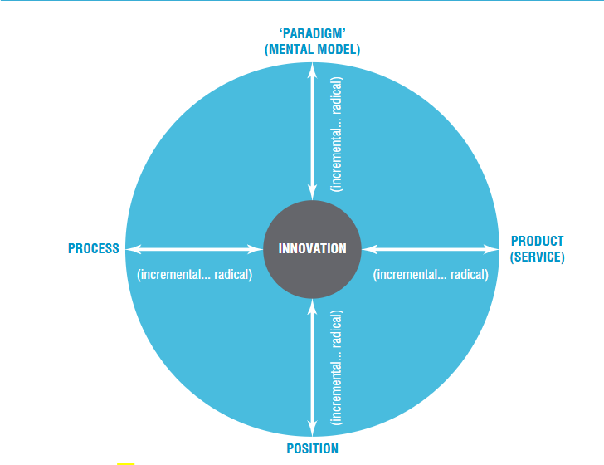

# Figure 1 : Model 4 Ps of innovation (Source: Bessant & Tidd, 2013)

In conclusion, these four dimensions highlight that innovation is not limited to new products but can also involve new ways of doing things, targeting different customers, or even creating entirely new business models.

**Why and How Innovation Matters?**

Innovation is the cornerstone of survival and growth, impacting individual enterprises and driving national economic progress.The economist William Baumol pointed out that ‘virtually all of the economic growth that has occurred since the eighteenth century is ultimately attributable to innovation’. For example, In their regular survey of ‘innovation leaders’ in 25 sectors of the economy, the consultancy Innovaro reported that these companies not only outpace their competitors on a year by year basis but also that this has a marked effect on their share price. Over the past 10 years they have regularly outperformed the average share price index on the NASDAQ, Dow Jones and FTSE markets and in 2009, when other companies’ share prices grew on average by between 40 and 70%, the Innovation Leaders average growth was 130%. (Source: Innovation Briefing, ‘Innovation Leaders 2008’, [www.innovaro.com](http://www.innovaro.com)). Innovation is the catalyst for progress, enabling organizations and individuals to thrive in a competitive and ever-evolving world. By integrating new ideas and technologies, innovation enhances productivity, allowing greater output from the same resources. This ability to do more with less not only drives economic growth but also opens the door to new possibilities in healthcare and beyond.

Besides, Innovation is important because it drives progress, improves efficiency, and helps businesses stay competitive in a constantly changing world. For example, Citibank became the first bank to introduce automated teller machines (ATMs), making banking services more convenient and accessible for customers. This innovative idea not only set Citibank apart as a leader in technology but also transformed the banking industry by offering 24/7 access to basic financial services( Tidd et. al, 2011) . By embracing new ideas and improving how things are done, innovation creates better experiences for customers and helps businesses grow and succeed.

Innovation also addresses societal challenges and helps to improve the quality of life in public services like healthcare and education. According to the study by Prahalad & C.K., 2006, A notable example is the Jaipur Foot, an affordable prosthetic limb developed by Dr. Pramod Karan Sethi and sculptor Ram Chandra in India. The problem is compounded by the fact that many of those requiring new limbs are also in the poorest regions of the world and unable to afford expensive prosthetics. This artificial limb was developed using Chandra’s skill as a sculptor and Sethi’s expertise and is so effective that those who wear it can run, climb trees and pedal bicycles. It was designed to make use of low tech materials and be simple to assemble – for example, in Afghanistan craftsmen hammer the foot together out of spent artillery shells whilst in Cambodia part of the foot’s rubber components are scavenged from truck tyres. Perhaps the greatest achievement has been to do all of this for a low cost – the Jaipur foot costs only $28 in India. Since 1975, nearly 1 million people worldwide have been fitted for the Jaipur limb and the design is being developed and refined – for example, using advanced new materials.

All in all, Innovation is not a mere business strategy; it's a mindset, a way of life. It’s a relentless pursuit of excellence, a constant striving to improve and surpass limitations. It's the burning desire to make a difference, to leave your mark on the world. It's about seeing challenges not as roadblocks, but as opportunities for growth, for creation.

**A need to Change From Fixed To Growing Mindset**

Innovation is not only about developing new products or technologies; it is fundamentally about a shift in mindset. The change from a fixed mindset to a growth mindset is crucial for fostering innovation.

A fixed mindset is the belief that abilities and intelligence are static, meaning people with this mindset may avoid challenges, give up easily, and see failure as a reflection of their limitations. They often see failure as a reflection of their lack of ability, rather than as an opportunity to learn and grow. This mindset can limit personal growth and innovation because it discourages taking risks, trying new things, or putting in the effort needed to improve.

In contrast, a growing mindset is the belief that skills and intelligence can be developed through effort, learning, and persistence. People with a growth mindset see challenges as opportunities to grow, rather than as obstacles to avoid. They embrace effort, persist through setbacks, and view failure as a natural part of the learning process, not as a reflection of their abilities. This mindset encourages continuous improvement, creativity, and resilience. Individuals with a growth mindset are more likely to take risks, try new things, and seek out new experiences, which are all essential for innovation and personal development. This mindset allows for continual progress, embracing setbacks as part of the learning process rather than as barriers.

The ability to innovate requires an openness to change, a willingness to challenge the status quo, and a commitment to learning. Three key elements—curiosity, risk-taking, and resilience—are central to driving successful innovation. These elements help individuals and organizations not only to generate new ideas but also to navigate the inevitable challenges that come with implementing them.

### Curiosity: The Foundation of Innovation

Curiosity is the cornerstone of innovation. It fuels the desire to explore new possibilities, ask probing questions, and challenge existing assumptions. Innovators are naturally curious; they ask, *What if?* or *Why not?* instead of accepting things as they are. Curiosity leads to exploration beyond traditional boundaries, inspiring individuals to seek out new perspectives, uncover unmet needs, and discover novel solutions.

Research supports the critical role of curiosity in innovation. A study by *Harvard Business Review* found that curiosity-driven employees are more likely to introduce new products and processes that lead to a competitive edge. Moreover, companies with a culture of curiosity encourage employees to think creatively and problem-solve proactively, driving sustained innovation and growth.

**Risk-Taking: Embrace the uncertainties**

Risk-taking is another crucial element for innovation. To create something new, there is always an element of uncertainty and the possibility of failure. However, risk-averse attitudes stifle creativity and prevent breakthroughs. Innovators understand that risk is inherent to the process, and instead of fearing failure, they embrace it as a learning opportunity.

Many successful entrepreneurs and innovators, such as Steve Jobs and Elon Musk, exemplify the power of risk-taking in innovation. Musk's ventures, including SpaceX and Tesla, highlight how calculated risks can lead to disruptive change. According to *McKinsey*, companies that embrace risk and experimentation are more likely to lead in their industries. Moreover, research by *The Journal of Business Venturing* demonstrates that the most successful innovators often take risks by challenging conventional business models or entering uncharted markets.

### Resilience: Bouncing Back from Setbacks

Resilience is the ability to persist through setbacks and continue forward despite obstacles, which is vital for innovation. The path to creating something new is rarely smooth, and resilience allows innovators to navigate challenges with determination. When faced with failure or adversity, resilient innovators do not give up; instead, they learn from their experiences, refine their ideas, and try again.

Resilience has been identified as a key trait of successful innovators. A study published in *The Academy of Management Perspectives* showed that resilient individuals are more likely to continue pursuing innovation, even when early efforts do not succeed. Innovators understand that each failure is a step toward a better solution, which enables them to adapt and improve. This trait is particularly important in environments that require constant change and adaptation, where the ability to recover and iterate quickly is critical for long-term success.

The mindset required for innovation is built on a foundation of curiosity, risk-taking, and resilience. These traits allow individuals and organizations to think differently, pursue bold ideas, and persevere in the face of uncertainty. Innovation is not just about having great ideas; it is about developing the mental framework to bring those ideas to life. As industries evolve and markets become more competitive, fostering these mindsets will be essential for organizations aiming to lead the way in innovation.

**CHAPTER 3 TURNING IDEAS INTO REALITY: THE INNOVATION PROCESS**

**Diabetic Foot Ulcer**

Diabetes mellitus (DM) is a metabolic disease characterized by chronic hyperglycemia, caused by defects in insulin secretion and/or utilization. It is now become a concern in Malaysia, with rising prevalence rates that have made it a major public health issue.Approximately 150–170 million of the world’s population is suffering from this condition and its prevalence will most likely multiply by two folds by 2025 as per the World Health Organization (WHO) reports. The WHO has identified the leading 10 countries in Asia with a large number of people with DM including India, Japan, China, Korea, Bangladesh, Thailand, Indonesia, Philippines and Malaysia.( Zimmet et al, 2001) Malaysia has the highest rate of diabetes in Western Pacific region and one of the highest in the world, costing around 600 million US dollars per year.(Ganasegeran K et al., 2020) The prevalence of diabetes raised from 11.2% in 2011 to 18.3% in 2019, with a 68.3% increase.According to a national survey report, in Malaysia in 2019, 3.6 million adults (18 and above years) had diabetes, 49% (3.7 million) cases were undiagnosed.Diabetes is expected to affect 7 million Malaysian adults aged 18 and older by 2025, posing a major public health risk with a diabetes prevalence of 31.3%.

Long-term uncontrolled high blood sugar level will cause neuropathy and peripheral vascular disease, often leads to diabetic foot ulcers (DFUs) (Grennan D et al., 2019). Another Global studies revealed a 6.3% prevalence of DFU( McDermott K et al, 2023) while DFUs are a primary cause of nontraumatic lower limb amputations in diabetic patients( Lam et al., 2014), with about 20% of DFU patients requiring such amputations ( McDermott K et al., 2023). Another predictor for major lower limb amputation in patients with DFUs is more than three limb-salvaging surgeries ( Kow et al., 2019)

Eiser et.al. highlegted that amputation can give a negative impact on one’s quality of life in terms of physical function, physical role performance, social function, vitality and general health of an individuals compared to the normal population. The World Health Organization

Quality of Life (WHOQoL) Group described the term, quality of life (QoL) as an individual's perception of his/her position in circumstance of the culture and values in which he or she lives and with respect to his/her goals, expectations, principles, and concerns (Misselbrook, 2014).

On the other side, lower limb prosthesis has been shown to improve mobility, independence, cosmesis and quality of life following amputation ( Razak et al., 2016). According to World Health Organization (WHO), approximately 0.5% of the population of a developing country has a disability that will require a prosthesis or orthosis. This suggests that around 160,000 of Malaysia’s current population of 32.58 million will need prosthetic or orthotic devices. (Razak et al., 2016). Hence, this emphasize the importance of the prosthesis in improving amputees’s life and highlights the need for continuos improvement and innovations to deliver the best for the patients.

The pathophysiology of diabetic foot ulcers has neuropathic, vascular, and immune system components, which are associated with the hyperglycemic state of diabetes. Hyperglycemia produces oxidative stress on nerve cells and leads to neuropathy. *Vascular changes* that lead to diabetic foot ulcers correlate with hyperglycemia-induced changes in the peripheral arteries of the foot and begin on the cellular level.( Clayton et al.,2009) Immune changes include reduced healing response in diabetic foot ulcers. Increased T lymphocyte apoptosis, which inhibits healing, has been observed in patients with diabetic foot ulcers.(Arya et al., 2013)

DFU comprises a full-thickness wound involving the dermis, located in the weight-bearing or exposed area below the ankle.( Raja et al., 2023) The Diabetic foot ulcers can be classified based on their severity, depth, and presence of infection or ischemia. The Wagner Classification system is widely used and is based on wound depth and the extent of tissue necrosis (Table 1). However, this classification only accounts for wound depth and appearance and does not consider the presence of ischemia or infection. ( Frykberg RG, 2002).

| **Wager’s Ulcer Classification System** | |
| --- | --- |
| **Grade** | **Lesion** |
| 1 | Superficial diabetic ulcer |
| 2 | Ulcer extension involving ligament, tendon, joint capsule, or fascia with no abscess or osteomyelitis |
| 3 | Deep ulcer with abscess or osteomyelitis |
| 4 | Gangrene to portion of forefoot |
| 5 | Extensive gangrene of foot |

However, in the healthcare’s fast paced world, Artificial intelligence (AI) is now emerging as a useful tool for classifying medical images, enabling accurate detection, diagnosis, and categorization of diseases based on imaging data (Bajuri et al., 2025). Han et al. developed a deep learning artificial intelligence (AI) model using the YOLOv3 algorithm, integrating object detection and multiclass classification for the analysis of diabetic foot ulcers (DFUs). A dataset of 2,688 images was utilized to train the algorithm, with the objective of detecting and grading foot ulcers based on the Wagner classification. The performance of YOLOv3 was compared with two other AI algorithms, achieving a mean accuracy of 91.95%, compared to 89.41% and 90.36% for the other algorithms. For real-time validation, 37 patients with DFUs were assessed, demonstrating effective localization of ulcers without any grading misjudgments. These findings highlight the potential of YOLOv3 for accurate and real-time DFU analysis in clinical applications.

The University of Texas system is another classification system that addresses ulcer depth and includes the presence of infection and ischemia (Table 2).

| **University of Texas Wound Classification System** | |
| --- | --- |
| **Stages** | **Description** |
| Stage A | No infection or ischemia |
| Stage B | Infection present |
| Stage C | Ischemia present |
| Stage D | Infection and ischemia present |
|  |  |
| Grading | Description |
| Grade 0 | Epithelialized wound |
| Grade 1 | Superficial wound |
| Grade 2 | Wound penetrates to tendon or capsule |
| Grade 3 | Wound penetrates to bone or joint |

Of all the classification systems mentioned above, the Texas and Wagner’s systems classification are simple and easiest to use. However, inclusion of stage in the Texas system makes it a better predictor of outcome hence, it is more preferred and highly recommended (Oyibo SO et al. , 2001).

Diagnosing infection in DFU can be challenging, especially in inexperienced clinicians (Lipsky et.al , 2004).According to the 2012 Clinical Practice Guidelines for the diagnosis and treatment of diabetic foot infections published by the Infectious Diseases Society of America, infection is defined by the presence of at least 2 classic symptoms or signs of inflammation (erythema, pain, warmth, tenderness, and induration) or presence of purulent secretion. In this context, the laboratory biomarkers such as Procalitonin(PCT), C-reactive protein (CRP), Interleukins play a significant role in the early diagnosis and treatment of the diabetic foot ulcer ( Wang et.al, 2021) . In study by Zakariah et. al study, which included 128 diabetic patients with foot ulcers, divided them into 73 IDFU and 55 non-infected DFU (NIDFU) cases. This study concluded that PCT, hs-CRP and WBC levels were significantly higher in the IDFU group compared to NIDFU with hs-CRP demonstrated the highest AUC (0.91; p <0.001) followed by PCT (0.814; p < 0.001) and lastly WBC (0.775; p < 0.001). The best cut off value, sensitivity and specificity for the presence of infection in diabetic foot, were 3.47 mg/dL, 80% and 89% for hs-CRP, 0.11 ng/ml, 70% and 87% for PCT and 11.8x109 /L, 60% and 90% for WBC. This study suggest that while hs-CRP is a more sensitive and effective marker for diagnosing IDFU and correlates significantly with the grade of infection, PCT, although useful for distinguishing IDFU from NIDFU, adds limited value to current clinical practices.

Management of diabetic foot ulcers (DFUs) requires a comprehensive approach that addresses the multifaceted nature of the condition, including infection control, wound healing, and patient education. The management can be categorized into conservatives and surgical management. Surgical intervention is usually required in cases of retained purulence or advancing infection despite optimal medical therapy. Possible additional indications for surgical procedures include incision and drainage of an abscess, debridement of necrotic material, removal of any foreign bodies, arterial revascularisation and, when needed, amputation ( Armstrong et al., 2004)

Effective management often involves combination therapy with surgical intervention in the form of drainage and debridement or osseous resection especially when there’s presence of osteomyelitis (Bajuri et al., 2017). Virtual amputation is an alternative surgical approach in which the infected bone and ulcer site are debrided, allowing for faster wound healing and potentially shortening the duration of antibiotic therapy. In a case series reported by Padzil et al. (2019), six patients underwent virtual amputation in which the procedure involved removing segments of osteomyelitic bone and necrotic tissue. Despite the absence of structural bone support, the surrounding soft tissue provided sufficient coverage to maintain the affected part’s configuration, achieving satisfactory cosmetic outcomes. This approach has highlighted the potential of virtual amputation as a viable treatment option is likely to reduce healthcare cost and reserve functional foot.

The main pharmacotherapies in diabetic foot are analgesics and antimicrobial agents. Wound treatments aim to alleviate symptoms, promote healing and avoid adverse outcomes. According to study by Goh et al. (2020), diabetic foot infections (DFIs) are often polymicrobial, with 85% of patients exhibiting infections involving multiple organisms, such as *Pseudomonas aeruginosa* (19%), *Staphylococcus aureus* (11%), and *Bacteroides* species (8%).On the grounds that DFI’s are of polymicrobial aetiology, it is unlikely for a single antimicrobial agent to be effective against all the probable organisms isolated from diabetic foot infections.Gram-positive bacteria respond well to Vancomycin, while Gram-negative pathogens are effectively managed with Imipenem and Amikacin.

The most prevalent management modality for DFU is local care, in which many potential avenues of treatment can be utilized. These include wound dressings, human skin equivalents (HSEs), pressure offloading, total-contact casting (TCC), systemic hyperbaric oxygen, larvae therapy (maggot therapy), and topical growth factors ( Raja et al., 2023). Proper wound care is crucial for managing diabetic foot ulcers (DFUs) to prevent delays in healing and reduce the risk of complications. Wound dressings are typically categorized into two types: basic and advanced. The emergence of activated carbon cloth (ACC) dressing, which is one of the most advanced and cost-effective wound management products in today's healthcare market, has changed the paradigm of DFU management. ACC dressing is a type of wound dressing that uses a cloth made of activated carbon to promote wound healing. According to a study by Grennan D. in 2019 has highlighted the biocompatibility and effective adsorption properties of ACC dressing, making it well-suited for wound healing applications.Besides, a pilot randomized controlled trial study by Bajuri et al. in 2024 aimed to evaluate the efficacy of ACC dressing compared to standard silver-based dressing in patients with diabetic foot ulcers (DFUs) has successfully demonstrated that ACC dressing facilitated better ulcer healing in DFU patients than the silver-based dressing. These findings highlight the effectiveness of the ACC dressing over silver-based options for managing hard-to-heal lower extremity wounds in individuals with diabetes. ( Bajuri et. al, 2024)

Other adjuvant therapy for diabetic foot ulcers such as Negative pressure wound therapy, Maggot debridement therapy, Hyperbaric oxygen therapy are used to promote wound healing. Hyperbaric oxygen therapy (HBOT) is used to increase oxygenation and antimicrobial effects that can improve the healing of chronic ulcers. ( Faglia E et al.,1996; Brown GL et al., 1979; Marx RE et al., 1990) In recent studies, recommendations have included treatment with Hyperbaric Oxygen Therapy (HBOT) as an adjunctive treatment in managing chronic DFIs as they can accelerate wound healing and improve patients’ quality of life. ( Bajuri et.al 2017)

Innovative techniques are also able to aid in the treatment of diabetic foot ulcers. A study was done in 2023 which introduced a novel approach using 3D-bioprinted autologous minimally manipulated homologous adipose tissue (3D-AMHAT) with fibrin gel scaffolding to enhance the wound healing in diabetic foot ulcer patients. This pilot study demonstrated promising outcomes, with 70% of patients achieving complete healing within 12 weeks and significant wound size reduction over time. According to the data, autologous adipose tissue grafting using a 3D bioprinter, with the addition of fibrin gel that acts as a scaffold, promotes wound healing with high-quality skin reconstruction. This study has shown that 3D-bioprinted autologous minimally manipulated homologous adipose tissue (3D-AMHAT) with the addition of fibrin gel as a scaffold is a potentially effective treatment method for improving skin regeneration in patients with DFUs.( Bajuri et. al, 2023)

Patient education also plays a crucial role in managing diabetic foot ulcer with a study titled "*The Effects of Diabetic Foot Care Programme Towards Quality of Life Among Type II Diabetes Mellitus Patients in UKM Medical Centre (UKMMC)*" which evaluated the effectiveness of a structured diabetic foot care program on the quality of life and foot care behavior of Type II diabetes patients, the result has showed a significant improvements in foot care behavior, with pre-test scores increasing from M = 1.32 to M = 1.94 post-test (p < 0.001) with the program included "Diabetes Footcare" initiative and an accompanying pamphlet. The quality of life of the patients, measured across four subscales, also improved significantly (p < 0.001), though foot care behavior was not directly linked to quality of life changes. The study has successfully concluded that the diabetic foot care program was effective in helping patients adopt better foot care practices and this program proved to be a valuable strategy in enhancing both the foot care practices and quality of life of Type II diabetes patients( Abdullah et al. 2021).

In conclusion, diabetic foot ulcers is a global burden and can lead to serious complications, often resulting in prolonged morbidity, reduce quality of life, and increased healthcare costs. Therefore, early diagnosis and a multidisciplinary approach are vital for managing and preventing these ulcers, as timely intervention can significantly reduce the risk of progression to more severe complications, including amputation. Advanced technological modalities, such as stem cell therapy, innovative wound care solutions, and surgical interventions, have proven effective in treating patients. However, continuous efforts to improve patient education, optimize glycemic control, and refine therapeutic strategies remain essential in addressing this critical health issue.

**The Healthcare Revolution & The future of Healthcare**

Healthcare systems worldwide face significant challenges in achieving the "quadruple aim" of improving population health, enhancing the patient experience, improving caregiver satisfaction, and reducing the rising costs of care (Berwick et al., 2008; Bodenheimer et al., 2014; Feeley et al., 2017; Bajwa et al., 2021). These goals are increasingly difficult to meet due to the growing demand for healthcare services, the complexity of patient needs, and the strain on resources. However, the emergence of artificial intelligence (AI) offers a promising solution to these challenges over the years. By integrating AI into hospital settings and clinics, healthcare systems can improve the efficiency, accuracy, and speed of care delivery. AI-powered tools, such as predictive analytics, diagnostic algorithms, have the potential to enhance clinical decision-making, reduce errors, and streamline workflows. Additionally, AI can assist in managing patient data more effectively, enabling timely interventions that improve outcomes and quality of life. By leveraging AI, healthcare systems can not only address existing inefficiencies but also provide more accessible, affordable, and patient-centered care, ultimately contributing to the broader goals of the quadruple aim.

**What is Artificial Intelligence ( AI) ?**

AI refers to the science and engineering of making intelligent machines, through algorithms or a set of rules, which the machine follows to mimic human cognitive functions, such as learning and problem solving( Mc Carthy, 1998; Bajwa et al., 2021). AI includes various techniques such as machine learning (ML), deep learning (DL), and natural language processing (NLP) (Alowais et al., 2023)Machine learning is an important component of AI used in healthcare, it refers to to the study of algorithms that allow computer programs to automatically improve through experience( Mitchell, 1997). Whereas, Large Language Models (LLMs) are a type of AI algorithm that uses deep learning techniques and massively large data sets to understand, summarize, generate, and predict new text-based content. (Suleimenov et al., 2020; Davenport et al., 2019; Russell, 2010). It is being used in a wide range of health data applications, such as improving patient care through better diagnosis accuracy, streamlining clinical processes, and providing more personalized services. Deep learning is a class of machine learning programming technology that is based around learning from large data sets ( Alli & Alam, 2019; Dawoud et al., 2018).

Artificial Intelligence (AI) has become deeply integrated into science and technology, with the potential to revolutionize industries such as healthcare, education. It has the remarkable potential to predict accurate data by analyzing complex patterns and relationships within large datasets. Its ability to process and learn from vast amounts of information enables it to deliver precise predictions in fields ranging from healthcare to material science. For instances, one study used Artificial Neural Network (ANN) Modeling to predict the viscosity of graphene oxide-silica nanofluids based on inputs like temperature, volume fraction, and shear rate. The results demonstrated that ANN has outstanding outstanding performances in anticipate of the rheological behaviors established by numerical modeling of viscosity which reached in non-trained shear rates, temperatures and vol fractions ( Ahmad et al., 2021). Therefore, this predictive capability not only reduces the cost for experiments but also enhances efficiency and decision-making across industries, making AI an invaluable tool for innovation and discovery.

On the other hand, particularly in the healthcare domain, numerous studies have shown that AI can play a vital role in clinical diagnosis. It not only enhance the accuracy of diagnoses but also help healthcare professionals make faster and more informed decisions, ultimately improving patient outcomes. For example, In Vats et al., demonstrated that AI, using the Iterative Enhancement Fusion-based Cascaded (IEFCM) model, can significantly assist in clinical diagnosis by accurately identifying multiple diseases from chest X-ray images. The results showed that,the IEFCM model achieved 95.62% sensitivity, ensuring accurate detection of lung diseases, and 96.23% specificity, which denotes, the IEFCM model correctly identified the healthy people. Another study also successfully demonstrated the effectiveness of AI models in classifying chest CT images of COVID-19. The result shows that the classification accuracies achieved were 92.24% for ResNet-50, 94.07% for VGG-16, 93.84% for CNN, and 93.04% for CAENN. Among machine learning classifiers, the Nearest Neighbor (NN) algorithm showed the highest performance, with an accuracy of 94% ( Saman et al., 2021). Also, Kumar et al. explored the use of deep learning for classifying brain tumors in MRI images, specifically distinguishing between benign and malignant tumors. The study achieved remarkable accuracy, with a classification accuracy of 99.30% for benign tumors and 98.40% for malignant tumors using an improved ResNet-50 model. This model also showed significant improvements in precision, recall, and F1-score compared to existing methods, highlighting the potential of deep learning to improve diagnostic accuracy, enhance image fusion quality, and enable more reliable tumor classification in clinical practice. Furthermore, deep learning algorithms are used to detect pneumonia from chest radiography with sensitivity and specificity of 96% and 64% compared to radiologists 50% and 73%, respectively ( Becker et al., 2022). AI has been making significant strides in various fields of medicine, and orthopedics is no exception. Koo et al. published a study aimed at evaluating a deep learning-based algorithm to enhance the reproducibility of radiographic measurements of the Meary angle and calcaneal pitch for diagnosing Pes Planus. Their findings demonstrated that the deep learning algorithm used to measure the Meary angle from radiographs produced statistically significant results (P<.05), highlighting its potential to improve the accuracy and consistency of radiographic assessments in diagnosing this condition. It also has the potential to recognition of potentially cancerous lesions in radiology images( Fakoor et al., 2013; Davenport et al., 2019). It is nowadays increasingly being applied to radiomics, or the detection of clinically relevant features in imaging data beyond what can be perceived by the human eye ( Vial et al., 2018). These findings has successfully highlighted that AI has the potential in reducing diagnostic errors and improving healthcare outcomes.

Besides the clinical diagnosis, AI also proved to be able to contribute in managing patients. AI has emerged as a valuable tool in advancing personalized treatment, offering the potential to analyze complex datasets, predict outcomes, and optimize treatment strategies ( Quazi , 2022; Subramanian, 2020). The ability to provide real-time recommendations relies on the advancement of ML algorithms capable of predicting patients who may require specific medications based on genomic information. The key to tailoring medications and dosages to patients lies in the pre-emptive genotyping of patients prior to the actual need for such information. (Johnson et al., 2021; Pulley et al., 2012). This is supported by a study conducted by Huang et al., in which ML was used to predict the response of 175 cancer patients to various standard-of-care chemotherapies by incorporating their gene-expression profiles, resulting a high prediction patient response >80% accuracy. These findings has highlighted the promising role of AI in predicting treatment responses, potentially aiding in personalized treatment planning and improving patient outcomes.

Overall, AI is revolutionizing healthcare by enhancing diagnostic accuracy, improving treatment personalization, and streamlining clinical workflows. Through its applications in medical imaging, predictive analytics, and treatment response prediction, AI has demonstrated its potential to support healthcare professionals in making more informed decisions and providing better patient care. Studies have shown that AI can reduce diagnostic errors, improve prediction accuracy, and enable earlier detection of conditions, ultimately contributing to improved patient outcomes. As AI technologies continue to evolve, their integration into healthcare systems will likely become increasingly crucial in advancing medical practice, optimizing resource utilization, and reducing healthcare costs, paving the way for a more efficient and effective healthcare future.

**The Impact of Virtual Reality in Helthcare Field**

As technology advances, Virtual Reality (VR) has increasingly used in the healthcare field, emerging as a powerful tool that enhances medical practices and patient outcomes. VR is a innovative technology that generates immersive, virtual environment enabling the users to interact and visualize the real world in a virtual setting through multiple sensory channels (Riva & Widerhold, 2002; Burdea, 2003).

With the rapidly developing technology, VR inntervention has been utilsed in diverse healthcare applications, such as conducting experiments, treating various medical conditions and studying user experiences with this new technology ( Adams et al., 2018; Burdea et al., 1994; Ma et al.,2018; Rothbaum et al., 2001). Additionally, VR plays a significant role in managing patients, for example treating chronic pain ( Li et.al, 2011), Gait rehabilitation post surgery ( Gianola et al., 2020) & post - stroke ( Rooij et al.,2016) , exposure therapy (Spytska, 2024; Kothgassner et al.,2019) and social skills training for autism patients ( Ip et al., 2018; Yuan et al., 2018; Ke at al., 2022; Kourtesis et al., 2023). VR also plays a role in transforming healthcare education, by providing immersive, interactive, and safe learning environments for medical professionals. By simulating real-world scenarios, VR enables learners to practice complex medical procedures, enhance their decision-making abilities, and gain a comprehensive understanding of anatomy and patient care without exposing real patients to any risk. Some applications of VR in medical education include virtual surgeries for ophthalmology, laparoscopic and endoscopic techniques, anatomy dissections, emergency simulations, and procedural training (Sowndararajan et al., 2008; Slater et al., 2016; Jang et al., 2017; McGrath et al., 2018; McCarthy, 2019).

One significant advantage of VR-based training in healthcare is that it provides a risk-free and controlled approach to training medical personnel, reducing the potential dangers associated with traditional training methods that involve direct patient interaction (Fertleman et al., 2018; Sahi et al., 2020). Unlike conventional clinical education, which relies on hospital-based training or mannequin simulations, VR-based education overcomes the limitations of time, space, and the restricted variety of clinical cases (Hall et al., 2020). VR offers healthcare professionals the flexibility to engage in repeated practice at any time and in any location, allowing them to experience a broader spectrum of real-world clinical situations (Chen et al., 2020; Jiang et al., 2022; Barteit et al., 2021). Moreover, VR-based education has been shown to enhance students' skills, build self-confidence, and improve overall satisfaction with clinical knowledge and competencies (Chen et al., 2020; Chao et al., 2021; Chao et al., 2023; Schoeb et al., 2020; Ammanuel et al., 2019; Cobbett et al., 2016; Dunlop et al., 2024; Lee et al., 2023; Salameh et al., 2024; Lim et al., 2023). However, VR-based education also comes with certain challenges, such as the high cost of development, the need for specialized equipment, and the possibility of visual fatigue for users (Jensen et al., 2018).

In addition to its vast potential in medical education and training, the integration of ontologies into Virtual Reality (VR)-based systems provides a unique advantage by effectively structuring and organizing knowledge within the healthcare domain. A study by Ummul et al. evaluates the role of ontologies in enhancing VR-based training systems in healthcare. Ontologies play a key role in improving knowledge sharing and enabling system interoperability, making the development of VR-based training (VRT) more efficient and reusable.

However, despite their significant potential to enhance VRT development in healthcare, the adoption of ontologies is still in its infancy due to the limitations such as difficulties in maintaining a standardized vocabulary, inadequate information exchange and communication to support the development process, insufficient user-centric designs, and the lack of integration of appropriate learning theories.

Hence, to address these challenges, a comprehensive strategy to create and effective ontology for VR Training was proposed which may include (1) tackling the base of knowledge for VRT in healthcare, (2) Enhance ontology design by considering the requirements from various stakeholders and adopting advanced ontology design principles such as the upper ontologies system, (3) identifying well-defined learning theories or models to strengthen the foundations, and (4) becoming part of the solution to VRT limitations. These steps aim to unlock the full potential of ontologies in revolutionizing VR-based training in healthcare, ensuring it is both impactful and widely applicable.

While there are challenges to address, the promise of this powerful technology offers many exciting opportunities that could reshape the healthcare field. From AI-driven diagnostics and treatment planning to VR-based medical training and therapy, these technologies have shown the potential to transform how healthcare is delivered. Therefore, continued advancements and innovations are essential and required to create a more efficient, accessible, and inclusive healthcare system, driving a new era of excellence and transformation.

**CHAPTER 4 OUT OF THE LAB: COMMERCIALIZING INNOVATIONS**

*‘To turn really interesting ideas and fledgling technologies into a company that can continue to innovate for years, it requires a lot of discipline.’*

– Steve Jobs

### The Innovative Journey

### With the high numbers of amputees, many patients often find dissatisfaction with the existing prosthetic limb in the market. The conventional prosthetics are usually designed for basic activities like standing, walking, and running only, fall short in addressing movements that require greater flexibility, balance, and control. A recent local study found that only 80% of the amputees interviewed had prostheses and among those, only 80% of them actually used them. Nearly half of them reported their prostheses were uncomfortable.( Van Damme H et al., 2006) Furthermore, walking with prosthesis required more energy for these mostly frail patients(Wan Hazmy et al., 2006). Besides, the Muslim amputee patients face additional challenges during prayers, as they must remove their prosthetic limbs, making the process more difficult and inconvenient.

### In addition, the existing prosthetics and orthopedic shoes often cost thousands of ringgit, making the low-income households, especially, the B40 population inaccessible to the custom made orthopaedic shoes. To address this challenge, efforts were made focused on reducing costs by 50%, aiming to make prosthetic limbs more accessible while ensuring that they offer the necessary comfort and flexibility. The goal was not only to help individuals regain mobility but also to improve their overall well-being and ability to engage in daily activities like prayer, which holds particular importance for Muslim amputees.

### Thus, developing an affordable prosthetic design is essential to provide patients with improved comfort and functionality. With the goal to provide effective prostheticservices that can help amputees gain independence, mobility, and resume their lives normally, Ortonesia Enterprise with the support of Universiti Kebangsaan Malaysia (UKM) has come out with a transtibial prosthetic foot and ankle assembly as known as, MyB Muslim Prosthetic, a user-friendly prosthetic leg specifically tailored for Muslim lower-limb amputees, offering greater flexibility and comfort, especially during prayers.

The transition from an idea to a good prototype was a far more complicated process than I initially anticipated. The initial research involved a deep dive into the existing literature on prosthetic design, biomaterials, and biomechanics. Many countless hours were spent poring over scientific journals, attending conferences, and engaging in discussions with colleagues and experts in the field. This phase was crucial in understanding the limitations of current prosthetic designs and identifying potential areas for improvement.

One of the challenges of the early stage was the selection of appropriate biomaterials. The material had to be strong enough to withstand the stresses and strains of daily use, yet biocompatible enough to minimize the risk of rejection or inflammation in the patient's body. Rigorous testing was crucial, involving both in vitro and in vivo studies to assess biocompatibility, mechanical strength, wear resistance, and fatigue life. The biomechanical design of the prosthetic was another significant hurdle. The computer-aided design (CAD) software was utilized to model and simulate the articulation and load-bearing characteristics of the prosthetic.

Prototyping was an important stage in the development of the MyB Muslim Prosthetic. The development of a robust and reliable testing protocol was essential in ensuring the efficacy and safety of the prototype. However, developing the **MyB Muslim Prosthetic** prototype was far from easy—it was a journey filled with challenges, setbacks, and relentless determination. Asie from that,securing funding for this research was a continuous challenge. Early-stage research is often underfunded, and securing grants and attracting investment can be difficult. The process began with creating the first prototype, which was self-funded. The team worked tirelessly to develop a design that would cater to the specific needs of Muslim lower-limb amputees. The key focus was to offer a prosthetic leg that would provide comfort, functionality, and ease of use during daily tasks, especially during prayers. The flexibility of the prosthetic design was critical, ensuring that the wearer could easily adapt to different positions and movements required during prayer. These tests involved evaluating the prosthetic's mechanical strength, fatigue life, wear resistance, and biocompatibility. Data collected from these tests informed further design refinements, ensuring that the prosthetic was both durable and biocompatible. The creation of the first functional prototype was a watershed moment. Early prototypes exposed several weaknesses—issues with the socket material, the waterproofing, and the ankle dorsiflexion mechanism were among the significant obstacles. Each setback demanded a return to the drawing board, prompting countless revisions and improvements.Rigorous testing protocols were essential to ensure the prototype’s safety and reliability. Mechanical strength, fatigue resistance, wear durability, and biocompatibility were all evaluated through exhaustive trials. Data from these tests informed the design refinements, ensuring the prosthetic could withstand real-life conditions while maintaining user comfort.The results came with the creation of an improved prototype that included an automatic ankle dorsiflexion mechanism, better waterproofing, and lighter materials made locally. These changes fixed the earlier problems, making the prosthetic more durable, practical, and easy to use. Despite the difficulties, the process showed that with determination, teamwork, and creativity, even tough challenges could be overcome. The prototype was then delivered to five Malaysian hospitals targeting the B40 population, hoping that new prosthetic innovation able to improve the Quality of their lives. The team then conducted a survey using the SF-36 form to evaluate patient health and functional improvement after using the prosthetic. The result revealed that majority of patients reported significant improvement in overall health and functional outcomes, indicating satisfaction with the innovation.

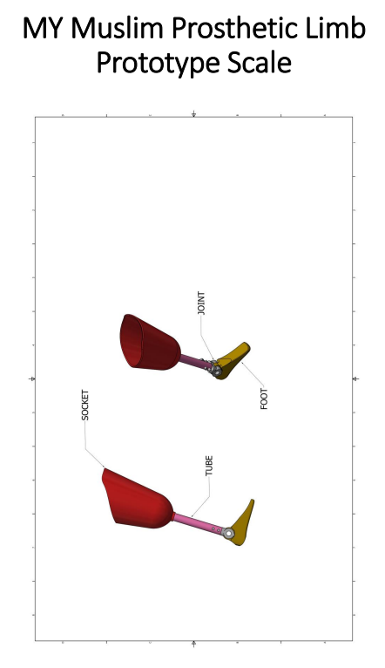

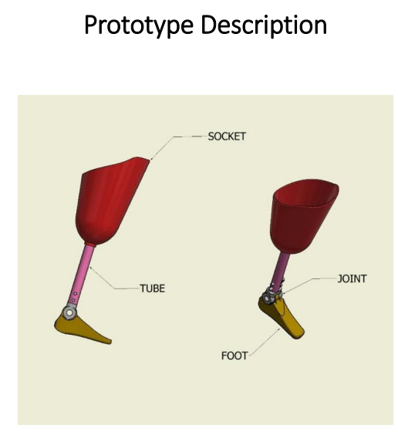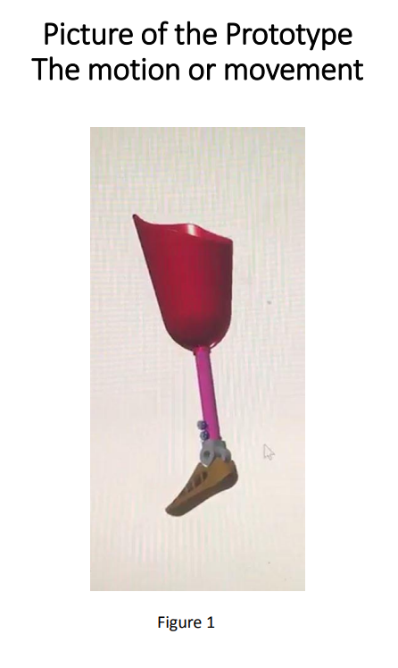

Once the prototype was successfully created, the next step was to seek IP Protection. In July 2023, the design was granted a patent, securing intellectual property rights and protecting the unique aspects of the MyB Muslim Prosthetic. This was a major milestone, validating the innovation and offering reassurance that the design was original and beneficial to the community. Securing intellectual property (IP) protection is paramount in the journey from research to innovation, particularly in the competitive landscape of medical technology. Patent protection offers exclusive rights to an invention for a limited period, allowing the inventor (or assignee) to exclude others from making, using, selling, or importing the invention without authorization.

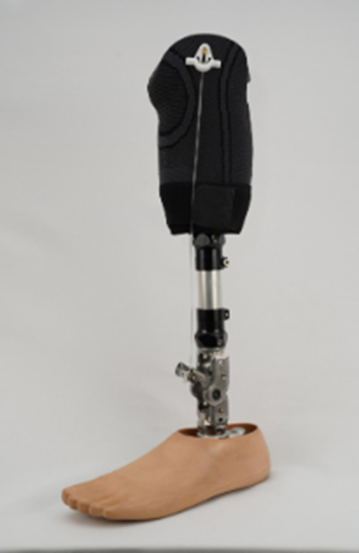 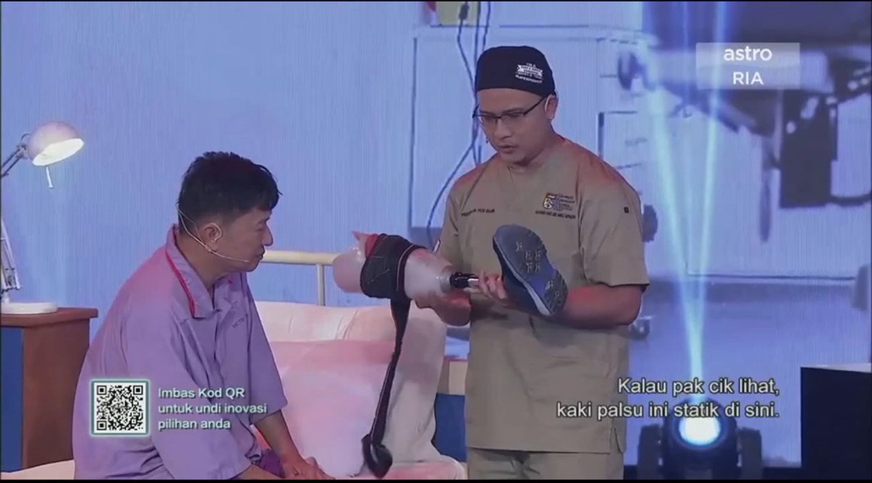

The scientific validation of the prosthetic technology was as crucial as securing intellectual property rights. Validation was carried out with the support of the MOSTI MysI fund, which allowed for the funding of the validation phase. This stage was crucial as it provided the opportunity to test the prosthetic on real users, ensuring that it met their needs and expectations. Before even considering commercialization, the technology needed to stand up to the scrutiny of the scientific community. This involved a multi-stage process, beginning with extensive in-vitro testing. We meticulously assessed the biocompatibility of the materials used, ensuring minimal risk of adverse reactions in the human body. This involved rigorous testing of the prosthetic's resistance to corrosion, fatigue, and wear and tear under simulated physiological conditions. These tests were not simply performed in-house; they were conducted in accredited independent laboratories to maintain the highest standards of objectivity and reproducibility. The data generated from these tests formed the bedrock of our subsequent research publications.

The next, and perhaps most significant, step was the clinical trials. This phase involved human subjects, and hence, required even more stringent ethical review and regulatory approvals. We collaborated closely with ethics committees and regulatory bodies to ensure complete compliance with all relevant guidelines and protocols. The clinical trials followed a rigorous, multi-center design, involving a diverse patient population to ensure the generalizability of our findings. Data was collected meticulously, with each patient's progress monitored closely and documented thoroughly. The statistical analysis of this data was performed by independent biostatisticians, minimizing potential biases and ensuring the integrity of the results. This rigorous approach to clinical trials ensured a high level of confidence in the safety and efficacy of the prosthetic technology. The successful completion of the clinical trials provided us with compelling evidence to support the claims of our technology's superiority. The project has benefitted 50 amputees, all from the B40 population, providing them with a functional and comfortable prosthetic that helped to improve their mobility and quality of life. This validation phase was not only important for confirming the design's effectiveness but also for gathering feedback from users that would inform further improvements and refinements.

The MyB Muslim Prosthetic was later upgraded to the newly designed MyB Transfemoral Prosthetic Limb with an Ankle Hinge. These advanced prosthetic limbs are user-friendly, multifunctional, and more affordable than most options on the market. Designed with a four-bar axis and single-axis movement, this above-knee prosthetic limb offers greater mobility and comfort for users. One of its key features is the ability to rotate, making it easier to use. Additionally, the prosthetic ankle can bend up to 180 degrees, a significant benefit for Muslim users or individuals who need to perform prostration, kneeling during prayer, or other activities like yoga or sitting cross-legged. The ankle flexibility also supports movements involving folded ankle positions.This innovative prosthesis stands out from existing market options due to its unique design configuration and choice of materials. The internal mechanism utilizes stainless steel for the single-axis four-bar system, while the exterior is covered with durable nylon, ensuring strength, functionality, and a sleek design tailored to users' needs.

### The success of the prototyping and validation phases has played a key role in ensuring that the MyB Muslim Prosthetic is both practical and affordable, making a significant impact on the lives of those in need. By addressing the specific needs of amputees, especially within the Muslim community, and making the product affordable for low-income populations, MyB Orthopaedic Innovation is setting a new standard for accessible and functional prosthetics.

In the year 2023, this ground-breaking innovation took centre stage in INNOVATHON, a reality show by ASTRO, Ministry of Economy, and Ministry of Science and Innovation. The impact of the product resonated with the audience, earning it the People’s Choice Award. During the presentation, the prosthetic received a standing ovation, a testament to its transformative impact and the recognition of its profound significance in the field of prosthetic technology.

Following the success of the MyB Muslim Prosthetic, the design was further enhanced with the introduction of the newly designed MyB Transfemoral Prosthetic Limb with an Ankle Hinge.This new prosthetic limbs are designed to be user-friendly, multifunctional, and remain more affordable compared to most other options available on the market. This step was essential in expanding the range of solutions for amputees, particularly those who require an above-knee prosthetic, which brings a higher level of mobility and usability.The MyB Transfemoral Prosthetic Limb is built with a four-bar axis and single-axis movement, making it more dynamic and responsive to the user's natural gait. These design elements significantly improve the mobility of the user, offering a more comfortable and fluid walking experience. One of the standout features of this new design is the prosthetic's ability to rotate, allowing for greater flexibility and ease of use. This rotation capability is particularly beneficial for users engaging in activities that require pivoting or changes in direction.

Additionally,the major advancement is this innovation is it can bend up to 180 degrees, a significant benefit for Muslim users or individuals who need to perform prostration, kneeling during prayer, or other activities like yoga or sitting cross-legged. The features also supports movements involving folded ankle positions.This innovative prosthesis stands out from existing market options due to its unique design configuration and choice of materials.

The design and materials of the MyB Transfemoral Prosthetic Limb are carefully chosen to ensure both strength and comfort. The internal mechanism utilizes stainless steel for the single-axis four-bar system, while the exterior is covered with durable nylon, ensuring strength, functionality, and a sleek design tailored to users' needs. This combination of materials makes the prosthetic both reliable and functional, while also keeping the overall design lightweight and user-friendly.

Every invention and publication was a testament to his determination. It was as if he held a magical lantern, illuminating the way for those shrouded in darkness. The mission of the prosthetic limb innovation was to ensure that diabetic patients could not only survive but also thrive in society. As they say, “Necessity is the mother of invention ”; and necessity fuelled his innovation. With 100 research publications and an impressive 826 citations, Prof Dr Mohd Yazid’s work resonated far and wide. His innovative approach was not limited to prosthetics; it encompassed wound management and post-operative recovery.

### Other Patents

### With a grant of RM274,000 from the Ministry of Energy, Science, Technology, Environment, and Climate Change, MyB Orthopaedic Innovation also introduced another two groundbreaking innovations:

### MyB Shoe Air Walker Integrated with Weight Alert System: A walking aid designed for patients recovering from fractures or ligament injuries. Equipped with advanced sensors, it detects excessive pressure on the injured leg, enabling patients to adjust their posture and gait for better healing outcomes.

### MyB Ortho Shoes: Custom-designed footwear tailored for diabetic patients prone to foot diseases, ulcers, and wounds. These shoes are created under the guidance of orthopedic specialists and can be prepared within just two days, addressing the specific needs of each patient.

### In addition to the groundbreaking prosthetic innovations, several other patents have been registered and are available, covering a range of advancements in healthcare and medical technologies. These include the Virtual Reality (VR) Platform or Applications or Modules for VR-based Education and Training (VRT) in Healthcare domain,Virtual Reality in Total Ankle Replacement Surgery, Transtibial Prosthetic foot and ankle assemble, external fixation tool, Dual Density Hydroxyapatite Scaffold, Total Ankle Replacement Digital templating software.

* **Optical Goniometer device for continuous monitoring of the knee movement in physiotherapy application**: This medical device is capable of monitoring, measuring, and assessing the health condition of the knee joint. The angular movement of the knee joint is continuously recorded, and the results are displayed on a laptop screen. Based on the obtained results, physiotherapists can evaluate the health condition of the knee joint, determine if the knee has experienced any previous injuries, and provide advice on the best steps to take for maintaining knee joint health, improving its condition, or preventing future injuries.
* **MyWound Solution & My Wound Care**: The development of a novel wound care solution builds upon the strengths of existing options, including products like Hydrocyn Aqua®, Dermacyn™, Prontosan®, and Octenisept® which recognized for their effectiveness in cleaning external wounds and reducing the risk of infections, each offering unique advantages in promoting wound healing.
* **Methodological Phases for Production of the Virtual Reality (VR) Platform or Applications or Modules for VR-based Education and Training (VRT) in Healthcare domain:** In light of the COVID-19 pandemic, pandemic preparedness training has become essential for healthcare personnel. During such crises, healthcare workers, including doctors and nurses, face significant risks of infection while handling human samples and treating patients. Since pandemics are often caused by pathogens with unknown severity, the readiness and preparedness of healthcare workers play a critical role in effectively managing these situations. This scenario highlights the potential applications of Virtual Reality Training (VRT) in the healthcare domain. By simulating realistic environments and scenarios, VR platforms can provide healthcare workers with comprehensive, hands-on training in a safe and controlled setting. Thus, developing VR-based education and training modules is an effective and innovative approach to enhance pandemic preparedness, equipping healthcare personnel to respond confidently and efficiently to future public health challenges.
* **Virtual Reality in Total Ankle Replacement Surgery:** This VR module offers a highly realistic and immersive simulation of total ankle replacement procedures, enabling surgeons to practice complex techniques in a risk-free virtual environment. The innovation not only enhances surgical precision but also allows users to identify and address potential challenges during the procedure. By simulating various scenarios, it prepares surgeons to handle complications effectively, ultimately improving patient outcomes.As the first of its kind in Malaysia, this VR-based module sets a new benchmark in surgical training, combining advanced technology with medical expertise to elevate the standards of orthopedic care.
* **External Fixation Tool (Development of MY Ankle Hinged Fixator):** MY Ankle fixator is designed for usage in the treatment of lower limb injuries such as open wounds or fractures. Soft tissue or bony healing occurs whilst at the same time providing some degree of stability to the affected bones, one of the aims of this hinged type external fixator. The other function is to allow some form of active mobilization that can reduce the incidence of joint stiffness secondary to prolonged immobilization.
* **Dual Density Hydroxyapatite Scaffold:** The Dual Density Hydroxyapatite Scaffold represents a breakthrough in tissue engineering, utilizing a rapid prototyping device to enable the swift fabrication of 3D model prototypes. This system integrates living cells into a meticulously designed 3D scaffold, replicating the structure and function of original tissues.It also acts as a containment structure to facilitate and guide tissue regeneration. This innovative approach bridges the gap between advanced prototyping and regenerative medicine, paving the way for enhanced healing and restoration of damaged tissues.
* **Development of Total Ankle Replacement Digital Templating Software:** Total ankle replacement (TAR) is the treatment of choice for primary osteoarthritis, inflammatory arthritis and posttraumatic arthritis ( Hinterman et al., 2012; Kachooei et al.,2022; Herscovici et al., 2018) This new innovation or software developed to help to evaluate and measure the actual size of implant to be used during ankle joint replacement surgery (total ankle replacement). It also enables surgeons to assess the need for nonstandard implant sizes, predict bony resection levels, avoid potential size mismatches, and anticipate the appropriate instruments required during surgery. Unlike conventional templating methods, which rely on acetate templates and radiographs and are prone to errors due to variations in radiographic magnification, digital templating software provides accurate, rapid, and reproducible planning. Additionally, the selected implant sizes can be saved for future reference, further enhancing surgical precision and efficiency. In a study by Mazli et al. evaluating the accuracy and inter-observer reliability of preoperative digital templating for tibial and talar component sizing in total ankle replacement (TAR) using the MyAnkle™ digital templating software, a retrospective analysis was conducted at UKM. The results revealed that the predicted sizes of the tibial and talar components were accurate in 83.3% and 91.7% of cases, respectively. For the second surgeon, the accuracy of size prediction was 66.7% for the talar component and 58.3% for the tibial component. The inter-observer reliability for both components was substantial, with a weighted kappa (κ) of 0.802 (95% CI, 0.623–0.982, p < 0.001). These findings indicate that the MyAnkle™ software is an effective and reliable tool for preoperative planning in TAR, enhancing precision in component sizing.

These patents represent a significant expansion of innovations aimed at improving healthcare practices, particularly in the fields of prosthetics, surgery, and medical training, making them more efficient, accessible, and effective for both practitioners and patients.

In conclusion, identifying unsolved problems is one of the important keys of successful innovation. It is the foundational moment—the initial spark that ignites the passionate pursuit of creating something truly remarkable. Each problem presents a potential solution,and a chance to develop something new that resonates with the target market and leaves a lasting impact. Innovation is rarely a straightforward journey; it demands resilience in the face of unexpected challenges and limitations. Navigating these hurdles, whether technical, financial, or logistical, tests the innovator's resilience and adaptability. By viewing challenges as opportunities for growth, innovators must learn to approach setbacks with determination, turning limitations into stepping stones for progress.

**Achievements**

The outstanding achievements and numerous awards are a testament to the unwavering dedication, groundbreaking innovations, and transformative contributions to the field of medical science and healthcare. These accolades are not just personal achievements; they are symbols of the impact my work has had on advancing medical innovation. Prof. Yazid has achieved remarkable recognition, garnering over 50 prestigious awards locally and internationally for his innovative contributions. Among the 50 awards I’ve been honored with, including international gold medals, one of the most significant is the recognition garnered by the MyB Prosthetic, a revolutionary below-knee prosthetic that has transformed healthcare for amputees.

Looking back at 2017, it was a year filled with remarkable recognition. I was fortunate enough to receive several prestigious awards, including the Gold Medal at the Invention and Innovations Awards 2017 for MyAnkleTM, and another Gold Medal at the International Invention Fair iENA 2017 for the MyAnkle Fixator. These early achievements were just the beginning. I also received the Gold Award at the International Trade Fair Ideas Invention and New Products (iENA) 2017 in Nuremberg, Germany, and the Gold Award at the GENEVA Awards 2017 in Geneva, further cementing the global recognition of my work. Additionally, I was honored with the Gold Award at the Persidangan dan Ekspo Antarabangsa Ciptaan Institusi Pengajian Tinggi (PECIPTA) 2017 in Kuala Terengganu. To cap it off, I was awarded the Japan Intellectual Property Association Best Technology Award at the Malaysian Technology Expo (MTE) 2017, highlighting the technological impact of my innovations.

In 2018, the recognition continued to pour in. I received the Gold Award at the Seoul International Invention Fair 2018 in Seoul, Korea, celebrating the technological advancements of my inventions. The Gold Award and Special Award at The British Invention Show 2018 in London further validated the global significance of my contributions to the medical field. That same year, I was honored with the Gold Award at the 10th International Exhibition of Inventions & 3rd World Invention and Innovation Forum 2018 in Foshan, China, reinforcing the international acclaim my work had garnered.

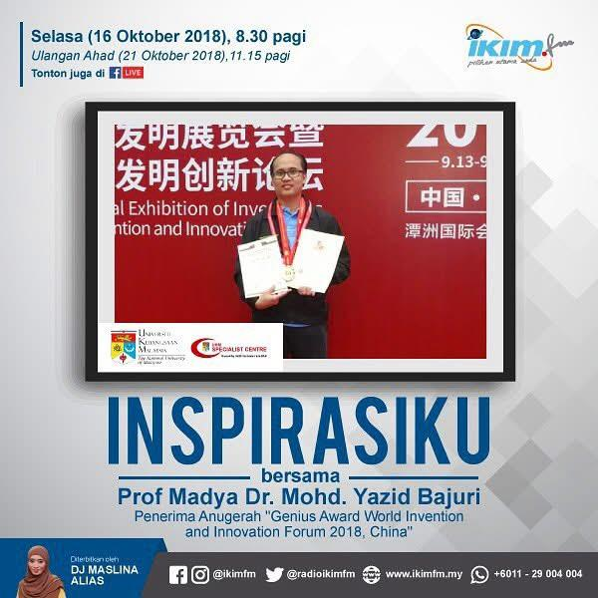

In 2019, I was once again honored with several prestigious awards that recognized my continued contributions to medical innovation. These included the Gold Medal at the International Conference & Exposition on Inventions by Institutions of Higher Learning (PECIPTA19) for my groundbreaking work on Virtual Reality in Total Ankle Replacement Surgery. I was also awarded the Gold Medal at the 30th International Invention, Innovation & Technology Exhibition (ITEX 2019), held at the Kuala Lumpur Convention Centre, Malaysia, further acknowledging the significance of my innovations. Additionally, I received the Gold Award at the Malaysian Technology Expo 2019 at PWTC in Kuala Lumpur. To top it off, I was honored with the Winner's Certificate at the Own It, Do It, Ace It: Pitch Your Innovation MCY@MScN 2019 program, held at Pusat Sains Negara, Kuala Lumpur, which was yet another recognition of my commitment to advancing healthcare through innovation.

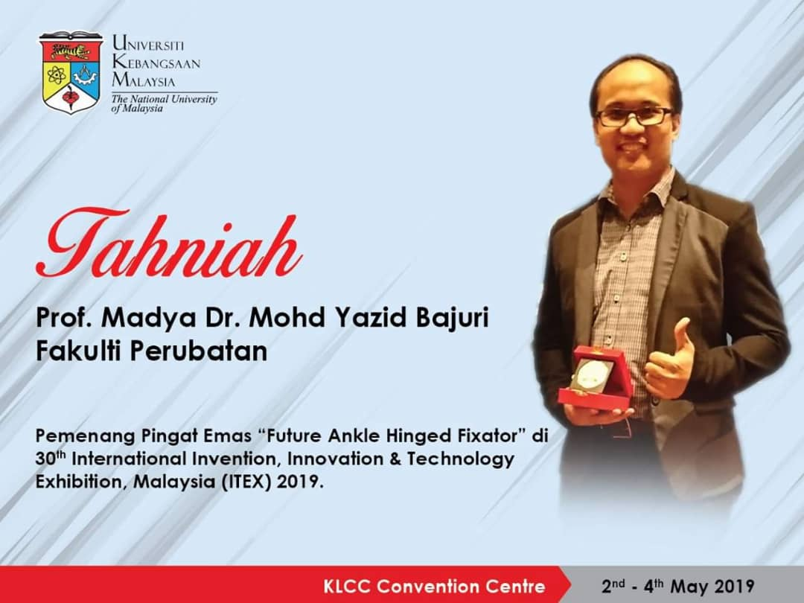

At the Malaysia Technology Expo 2020 (MTE 2020), I was grateful to receive two Gold Awards—one for the My Muslim Prosthetic and another for my work on Virtual Reality in Total Ankle Replacement Surgery. These recognitions highlighted the impact of these innovations in transforming the healthcare landscape. The recognition didn’t stop there. I also received the First Winner for Gold Award at the Kongres & Pertandingan Inovasi Pengajaran & Pembelajaran (kNOVASI) 2020, further underscoring the potential of Virtual Reality to revolutionize medical practices and improve patient outcomes.

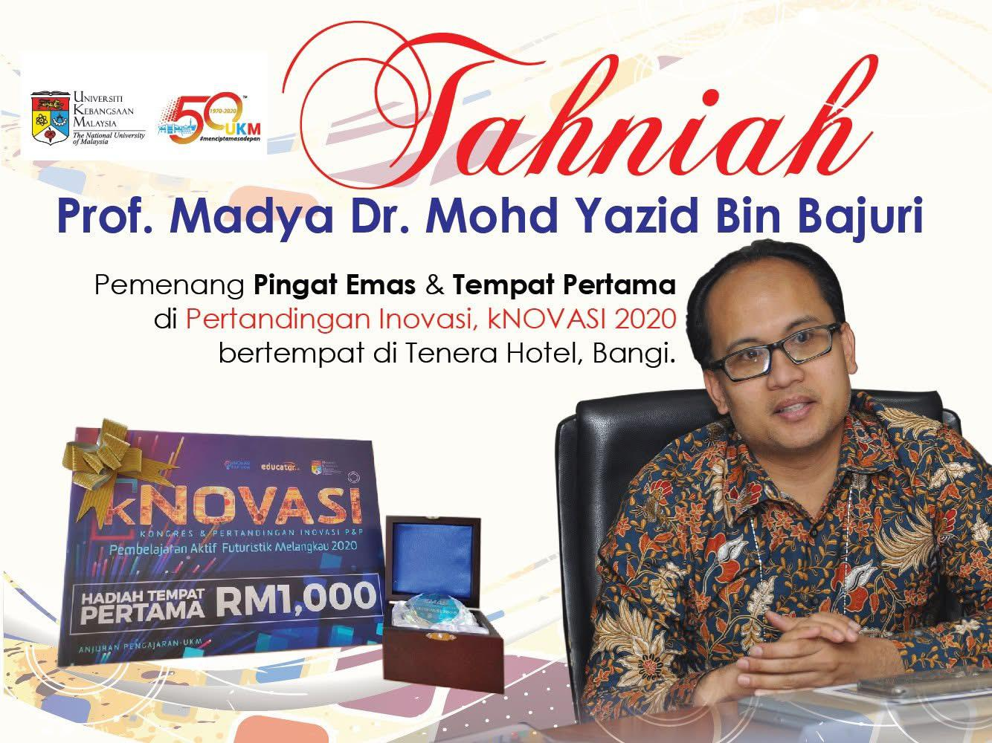 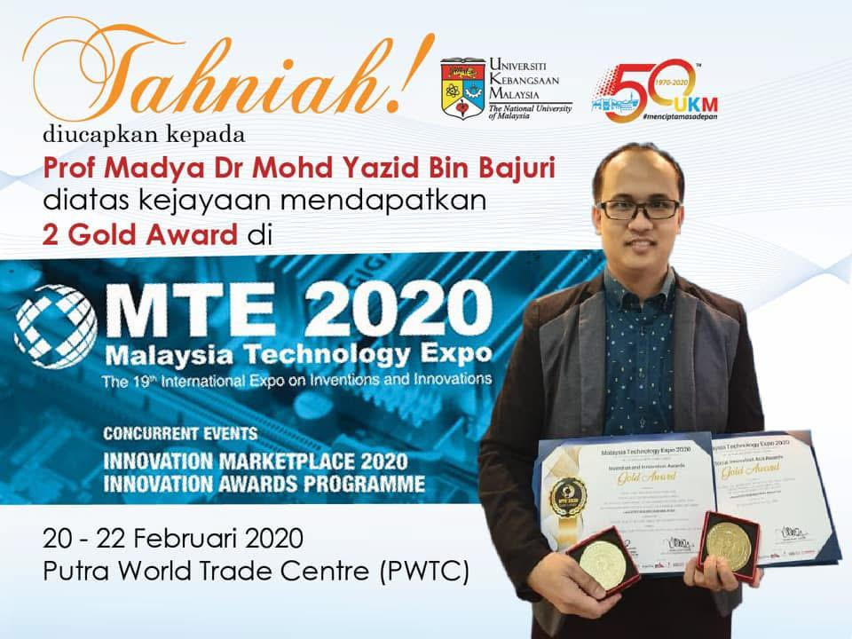

At the 32nd International Invention, Innovation & Technology Exhibition (iTex 2021), the MyB Prosthetic Limb emerged as a shining star, winning the Gold Award. This wasn’t just a trophy—it was a testament to the ingenuity and persistence that went into creating a prosthetic that transcended traditional limitations. The recognition didn’t stop there. The prosthetic also received the Best Invention Award and the KASS Best Invention Award at the same event, reinforcing its status as a groundbreaking innovation that redefines what is possible in healthcare.

The journey continued with the International Innovation Awards at the Malaysia Technology Expo 2021, where the MyB Transtibial Prosthetic Limb was awarded Gold. This wasn’t just about recognizing its technological sophistication; it was a celebration of the positive impact it has brought to the lives of amputees. The international stage further acknowledged the MyB Prosthetic with a Silver Award at the International Exhibition of Inventions of Geneva 2021, a reflection of its global appeal and the borderless nature of innovation.

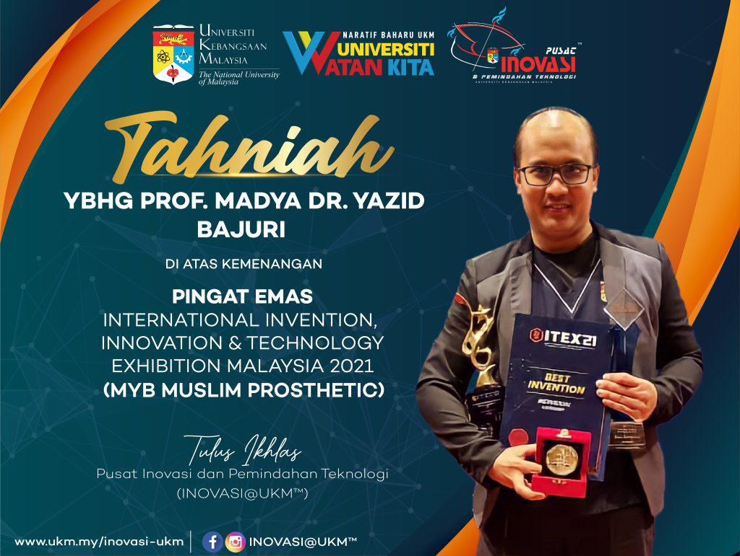

As time passed, my passion for advancing prosthetic technology continued to drive my work.I then received the Winner Prize at the MAS Innovation Award 2023, acknowledging my Biomechanical Evaluation and Clinical Testing of a Newly Developed Above-Knee Prosthesis with Enhanced Ankle Joint Movement. This recognition validated the groundbreaking contributions I made to the development of advanced prosthetic solutions. That same year, I was awarded the Silver Award at the 34th International Invention, Innovation & Technology Exhibition (ITEX 2023) for the MyB Ortho Shoe, further reinforcing the transformative impact of this healthcare solution in improving amputee care. In 2024, I was deeply honored to receive the Anugerah Kecemerlangan Inovasi (Bidang Sains & Teknologi) in the Profesor Category at the Anugerah Kecemerlangan MyRA UKM 2024. This prestigious award recognized my outstanding contributions to science and technology, and it served as a reminder of the journey I have embarked on—one driven by innovation, collaboration, and a commitment to improving lives through cutting-edge solutions.

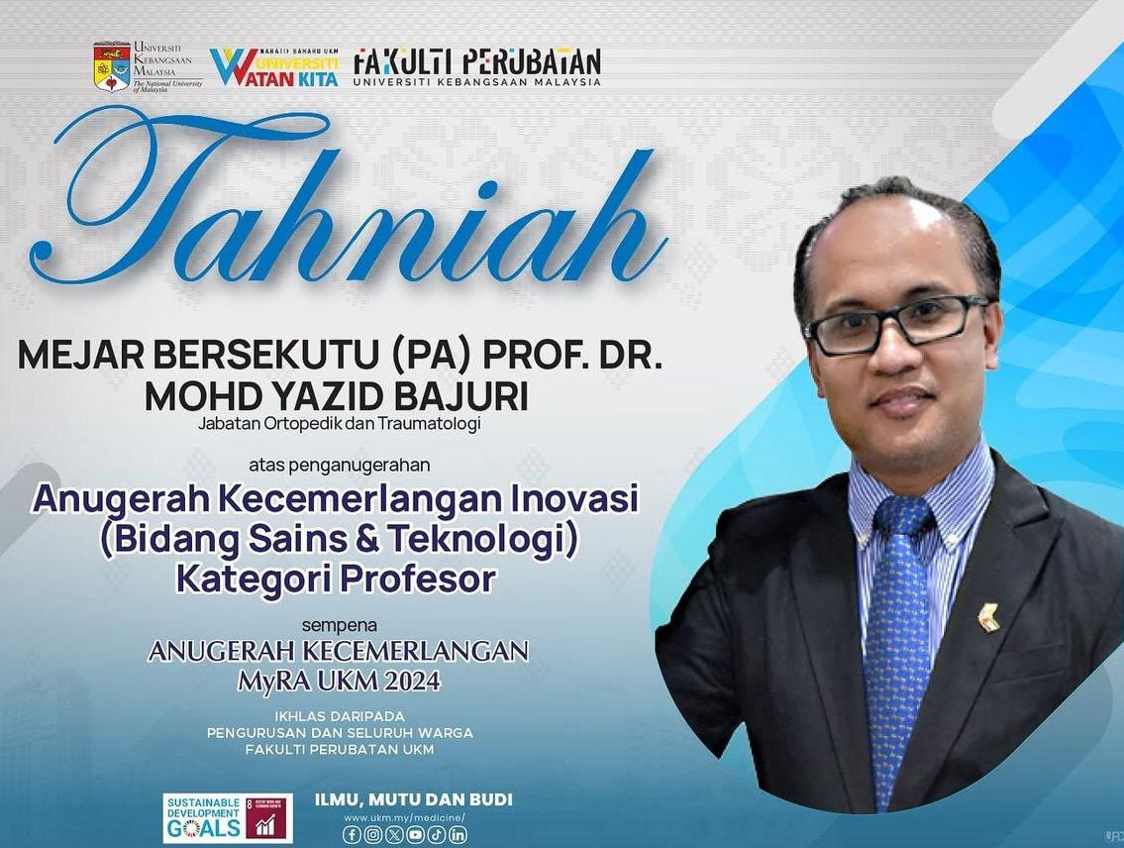

Each of these awards represents more than just personal recognition; they are milestones in a journey of continuous innovation, pushing the limits of what medical science can achieve. Every award is a reminder of the many lives impacted by these advancements and the endless possibilities that lie ahead.

Each award tells a story of persistence, excellence, and an unwavering commitment to improving lives. These recognitions are not just about the accolades; they embody the spirit of transformation that drives me forward.Beyond the awards, my work has always been about creating lasting change. One of the pivotal moments in this journey came in 2018, when I partnered with “Perbadanan Wakaf Selangor” established a Foot and Ankle Ward in Hospital Canselor Tuanku Muhriz (HCTM). This collaborative effort was more than just an addition to the hospital infrastructure,it was a symbol of the power of collaboration to effect meaningful change, bringing the best care for patients with diabetic foot ulcer.

In order to provide the best care for diabetic patients, I didnt not stop at research and innovation only. I saw a broader vision – a vision where my innovations reached the hands of those who needed them most. I participated in the “PEMULA” Programe by The Center for Innovation and Technology Transfer (INOVASI@UKM) which supports the government’s recommendations to produce more entrepreneurs as catalysts for technological and economic growth in line with the PEMULA@UKM program. This initiative aligns with the goals of the National Entrepreneurship Policy 2030 (DKN 2030), which aims to create a conducive entrepreneurial ecosystem and promote an entrepreneurial mindset in Malaysia. Since then, my company- MyB Innovation Sdn. Bhd. was established. Like a phoenix rising from the ashes, MyB Innovation Sdn. Bhd. emerged as a start-up company with a mission – to ensure that users could obtain high-quality prosthetics at reasonable prices. It was’t just a business; it was a lifeline, an embodiment of the saying, “Where there is a will, there is a way.” ; With a holistic approach and the concept of a social enterprise, MyB Innovation Sdn. Bhd. delivered high-end prosthetics at affordable prices, significantly improving the quality of life for those in need.

The transition from the lab to the marketplace is a defining moment in the journey of innovation. This chapter delves into the critical steps required to commercialize innovations, celebrate milestones, and ensure sustainable impact. Commercialization is not just about bringing a product to market; it’s about creating pathways for meaningful change and fostering innovation that transcends the boundaries of initial development.

The journey from concept to market launch requires a structured approach, beginning with thorough market research. Understanding the target audience, identifying potential competitors, and analyzing market trends are crucial for shaping a product's value proposition. Market research provides the insights necessary to position an innovation effectively, ensuring it meets the needs and expectations of its users.

A robust business model underpins every successful startup. This includes navigating dilemmas around pricing, cost structures, and potential challenges. For innovators, these considerations often involve a delicate balance between accessibility and profitability. Licensing business models, where intellectual property is shared with established companies, offer alternative pathways for commercialization, often reducing the burden of direct market entry.

Planning plays a pivotal role in translating ideas into a successful product launch. Product and marketing strategies must align with business goals, leveraging the right channels to reach the intended audience. Clear and actionable plans ensure that the innovation not only enters the market but thrives within it. Strategies for scaling the business, diversifying offerings, and capitalizing on growth opportunities are integral to long-term success.

As businesses grow, staying aligned with current trends is critical. Adapting to emerging technologies, changing customer preferences, and evolving industry standards helps maintain relevance and competitiveness. Innovators must remain forward-thinking, ensuring that their products and services continue to address pressing needs in innovative ways.

The impact of commercialization extends beyond prosthetics. Expanding innovation into fields like orthopedics, wound care, virtual reality (VR) surgery training, and ankle fixation devices demonstrates the versatility of advanced medical technologies. By leveraging expertise across these areas, innovators contribute to a broader landscape of healthcare solutions, improving patient outcomes and advancing medical practices.

The journey of launching MyB Innovation Sdn Bhd to the market and scaling the business was both exhilarating and challenging. As a startup company nurtured under the University Kebangsaan Malaysia (UKM) ecosystem, our path was marked by rigorous planning, innovative thinking, and strategic decision-making. This chapter delves into the pivotal stages of our journey, highlighting key aspects such as market research, developing a business model, navigating dilemmas, managing costs, addressing challenges, and executing a licensing business model with UKM. Additionally, the chapter explores our product and marketing strategies, along with our roadmap for sustainable growth.

#### Market Research: Understanding the Landscape

Market research was the foundation upon which MyB Innovation was built. We recognized early on that a thorough understanding of our target audience, competitors, and market trends was crucial. Our research focused on identifying gaps in the market, understanding customer pain points, and evaluating the potential demand for innovative solutions.

We conducted surveys, interviews, and focus groups with potential customers and industry experts. This primary research was complemented by secondary research, which included analyzing market reports, academic papers, and case studies. The insights we gathered helped us define our unique value proposition and differentiate ourselves from competitors. It became evident that our target audience sought solutions that were not only innovative but also cost-effective and user-friendly.

#### Developing the Business Model

Building a robust business model was the next critical step. We explored various business model frameworks, including B2B (business-to-business), B2C (business-to-consumer), and hybrid models. After careful deliberation, we opted for a licensing business model in collaboration with UKM. This model allowed us to leverage UKM's intellectual property and expertise while focusing on commercialization and market penetration.

Our business model was designed to balance innovation with sustainability. Revenue generation strategies included licensing fees, royalties, and direct sales. We also considered subscription-based models for certain products to ensure recurring income. Each aspect of the business model was meticulously analyzed to align with our long-term goals and vision.

#### Navigating Dilemmas and Decision-Making

Throughout our journey, we faced several dilemmas that tested our resilience and decision-making abilities. One of the primary dilemmas was choosing between rapid expansion and a more cautious, incremental approach. While rapid expansion promised quicker market dominance, it also carried significant financial risks. Ultimately, we decided to adopt a balanced strategy, focusing on establishing a strong foundation before scaling aggressively.

Another dilemma involved resource allocation. As a startup, we had limited financial and human resources, necessitating tough decisions about prioritizing projects and investments. We adopted a data-driven approach to decision-making, ensuring that each choice was backed by thorough analysis and alignment with our strategic objectives.

#### Managing Costs and Financial Challenges

Cost management was a constant challenge, especially in the initial stages of our journey. From research and development to marketing and operations, every aspect of the business required careful budgeting. We adopted a lean startup approach to minimize costs while maximizing efficiency.

Funding was another critical aspect. We secured initial funding through a combination of personal savings, grants from UKM, and investments from angel investors. As the business grew, we explored additional funding avenues, including venture capital and government programs. Financial planning and forecasting played a vital role in ensuring that we remained financially stable while pursuing growth opportunities.

#### Licensing Business Model with UKM

The licensing agreement with UKM was a cornerstone of our business strategy. This collaboration allowed us to access cutting-edge research and technology developed within the university. In return, UKM received licensing fees and royalties, creating a mutually beneficial partnership.

The licensing model also provided credibility and validation for our products, enhancing our marketability. It underscored the importance of building strong relationships with academic and research institutions to drive innovation and commercialization.

#### Product Development and Marketing Planning

Product development was driven by our commitment to addressing customer needs and delivering value. We adopted an iterative development process, incorporating customer feedback at every stage. This approach ensured that our products were not only innovative but also practical and user-centric.

Marketing planning was equally critical. We developed a comprehensive marketing strategy that included digital marketing, social media campaigns, and partnerships with industry influencers. Our marketing efforts were aimed at building brand awareness, generating leads, and converting prospects into loyal customers.

#### Strategies for Business Growth

Scaling MyB Innovation required a multi-faceted approach. Our growth strategy was built around three core pillars: market expansion, product diversification, and operational efficiency.

1. **Market Expansion:** We focused on entering new geographic markets and targeting additional customer segments. This included expanding our presence in regional markets and exploring international opportunities.
2. **Product Diversification:** To reduce dependency on a single revenue stream, we invested in developing complementary products and services. This diversification strategy not only enhanced our value proposition but also mitigated risks.
3. **Operational Efficiency:** Scaling required streamlining our operations and optimizing processes. We invested in technology and automation to improve productivity and reduce costs.

#### Challenges and Lessons Learned

The journey of launching and scaling MyB Innovation was fraught with challenges. From navigating regulatory requirements to managing competition, each challenge tested our resilience and adaptability. Key lessons learned included the importance of agility, the value of strong partnerships, and the need for continuous learning.

Regulatory hurdles were particularly challenging, requiring us to invest significant time and resources in ensuring compliance. However, these efforts also strengthened our credibility and trustworthiness in the eyes of customers and stakeholders.

The journey of launching MyB Innovation Sdn Bhd to the market and scaling the business was a transformative experience. It required a combination of strategic planning, innovative thinking, and relentless execution. Our success was built on a foundation of rigorous market research, a well-defined business model, and strong partnerships, particularly with UKM. While the journey was challenging, it also provided invaluable lessons and opportunities for growth. As we continue to scale, we remain committed to our vision of driving innovation and creating value for our customers and stakeholders.

**CHAPTER 5: GOOD TO GREAT: LESSON FROM THE JOURNEY**

### “Entrepreneurs are those who understand there is little difference between obstacle and opportunity – and are able to turn both to their advantage.”

### -Niccolo Machiavelli

The road to designing and providing affordable prosthetic limbs in Malaysia was not an easy one. It was a winding road filled with unexpected detours, steep inclines, and seemingly insurmountable obstacles. These weren’t simply minor glitches; they were full-blown crises that demanded immediate, decisive action and a willingness to adapt and learn. However, within these challenges lay opportunities—opportunities to innovate, grow, and make a lasting impact on the lives of others.

Securing funding is often one of the most significant barriers to innovation. In industries such as healthcare and prosthetics, the financial requirements are immense—ranging from research and development to prototyping, manufacturing, and scaling production. I faced these challenges head-on, learning that navigating the financial side of innovation would be a steep learning curve.

Early in the venture, I discovered that innovation in prosthetics required substantial financial backing. As a medical professional and not a business mogul, I had to think creatively. Initial funding came through partnerships with research institutions, investor pitches, and at times, personal contributions. These financial challenges were compounded by the need for specialized equipment, expert talent, and navigating the labyrinth of regulatory approvals.

**The Key Barriers to Entry**

### Financial Constraints and Securing Funding for Innovation

Securing funding is often one of the most significant barriers to innovation. In industries such as healthcare and prosthetics, the financial requirements are immense—ranging from research and development to prototyping, manufacturing, and scaling production. PI faced these challenges head-on, learning that navigating the financial side of innovation would be a steep learning curve.

**Competitors – Local Companies and Imported Products:**Before even considering manufacturing or securing funding, a thorough market analysis is crucial. This involves identifying the target patient population, defining the unmet clinical need our prosthetic technology addresses, and meticulously assessing the competitive environment. I faced stiff competition from local manufacturers and imported prosthetic products.

There was a clear gap in the market—affordable, durable, and well-designed prosthetic limbs that catered to the unique needs of Malaysians. However, breaking into this space required more than just a good product; it required building trust with users and proving that local products could match or even surpass the quality of their imported counterparts.

To tackle this, our team conducted extensive research, analyzing existing prosthetic technologies, their market share, pricing strategies, and their strengths and weaknesses. This wasn't merely a cursory review of competitor websites; it involved a deep-dive analysis, meticulously examining clinical trial data, user reviews, and patent filings.

**User Trust:**Perhaps the most challenging aspect of all was earning the trust of the patients themselves. Prosthetic limbs are not simply products—they are tools that define the quality of life for individuals who have already faced significant physical and emotional challenges. Convincing the patients to embrace a new, locally developed prosthetic limb was no easy feat. I spent countless hours meeting with patients, discussing their needs, and showing them the benefits of his innovative designs. Word of mouth became a crucial factor in overcoming this barrier. As satisfied users shared their positive experiences with others, trust slowly but steadily began to grow.

**Overcoming the Crossroads- The Challenges**

**Time Management:**

The challenges extended beyond the purely technical aspects.

Balancing my surgical practice with research demands was a major juggling act, requiring exceptional time management and prioritization skills. Developing the prosthetic limbs, attending to patients, conducting research, meeting with investors and partners—there never seemed to be enough hours in the day. Many late nights and weekends were spent in the wards, operating theatre and office, often sacrificing personal time and family commitments.

Although the sacrifices were significant, the support of his family and his dedication to making a difference kept him going. Although the sacrifices were significant, the support of his family and his dedication to making a difference kept him going.

**Uncertainties in Commercialization:**

Building upon the foundation of innovation and strategic partnerships, scaling the startup required a good understanding and proactive management of risk and uncertainty. From navigating regulatory approvals to understanding the market dynamics, there were no guarantees of success. Early tests of the product were met with some setbacks, as the team fine-tuned designs to improve comfort, durability, and function. Commercialization meant more than just creating a product—it involved educating the market, managing production costs, and understanding consumer behavior. Despite all the uncertainties, I remained opportunistics and committed to the goal of providing affordable, high-quality prosthetic limbs to those who needed them most.

**Building Blocks of Success: Key Lessons from the Innovation Journey**

Innovation is never going to be a *solo endeavor.*

Finding the right collaborators was crucial. These weren’t just business partners, but individuals who shared his vision, trusted his expertise, and were committed to solving real-world problems. Whether it was advice on technical aspects of prosthetics or guidance on business strategy, he understood the importance of leaning on others. No one has all the answers, and the willingness to seek help made all the difference.

In retrospect, the whole journey is a winding road filled with barriers, challenges, and setbacks but our team learned to enjoy the journey. The challenges weren't merely setbacks; they were opportunities to learn, adapt, and improve. Each challenge pushed the team to refine the processes, and develop better strategies. The ability to persevere, to maintain unwavering dedication in the face of adversity, is perhaps the single most critical factor determining whether an innovation will ultimately succeed or fail. This isn't simply about grit; it's about developing a resilient mindset, a strategic approach to problem-solving, and an unwavering belief in the potential of invention. Through persistence, collaboration, and a deep commitment to improving the lives of others, they are able to overcome the odds and make a lasting impact on the lives of patients.

##### Turning Setbacks into Opportunities

Each challenge faced by the team was an opportunity to learn, adapt, and improve. For instance, initial product designs that didn’t meet patient expectations prompted the team to iterate rapidly, resulting in better, more user-friendly designs. The journey underscored the importance of resilience, strategic problem-solving, and a growth mindset.

#### Reflecting on the Journey

The journey to design and deliver affordable prosthetic limbs was a winding road filled with barriers, challenges, and setbacks. Yet, for our team, these obstacles weren’t merely hindrances; they were catalysts for growth and innovation. Each hurdle refined their processes, strengthened their strategies, and deepened their commitment to making a difference.

Through persistence, collaboration, and an unwavering belief in the potential of their innovation, they succeeded in overcoming the odds. Their work not only transformed the lives of patients but also demonstrated that with the right mindset, even the most daunting challenges can be turned into opportunities.

*The journey often filled with obstacles , but for those who persevere,*

*The rewards are immeasurable.*

### CHAPTER 6: THE JOURNEY OF CHANGE - FROM ZERO TO ONE

Innovation is not merely the act of creating something new; it is a lifelong journey that transforms ideas into impactful realities. This journey, from "zero to one," represents the leap from nothingness to the creation of something original, meaningful, and transformative. It is a path filled with challenges, insights, and opportunities that shape both the innovator and the world they aim to improve.

#### Innovation as a Lifelong Journey

The process of innovation is never truly complete. Each breakthrough serves as a stepping stone for further exploration and discovery. As technologies evolve and societal needs shift, the role of an innovator demands continuous adaptation and resilience. Embracing innovation as a lifelong journey means recognizing that each milestone achieved is part of a larger narrative—a quest to push boundaries, solve problems, and create value.

Beyond the technical or tangible outcomes, the journey of innovation also fosters an intangible yet invaluable sense of purpose. The world’s greatest innovators, from inventors to social change leaders, have demonstrated that the process is as much about the personal growth it inspires as it is about the results achieved. Viewing innovation as a continuum ensures that each step—no matter how small or large—contributes to a greater legacy of transformation.

#### Becoming an Innovator: A Personal Path Forward

Becoming an innovator is as much a personal evolution as it is a professional one. It requires a mindset of curiosity, determination, and a willingness to embrace uncertainty. The path forward is unique to each individual, shaped by their experiences, passions, and vision for the future. Whether it begins with addressing a specific problem or exploring uncharted territories, the journey to becoming an innovator is defined by persistence and a deep commitment to making a difference.

One of the critical aspects of becoming an innovator is identifying one’s "why"—the driving purpose behind the innovation. This purpose serves as the compass that guides decisions, fuels perseverance, and aligns actions with meaningful outcomes. Innovators often find their "why" through personal experiences, observing inefficiencies, or witnessing struggles that spark a desire to create change. From there, the path becomes a fusion of creativity and pragmatism—a balance between dreaming big and grounding those dreams in actionable steps.

#### Continuous Learning: The Key to Evolving as an Innovator

Learning is the foundation of innovation. Staying informed about emerging trends, technologies, and methodologies is critical for staying relevant and impactful. Innovators must seek opportunities for growth, whether through formal education, collaboration, or self-guided exploration. Every challenge faced along the way is an opportunity to learn, adapt, and refine one’s approach. Continuous learning ensures that an innovator’s journey remains dynamic, resilient, and aligned with the changing landscape of the world.

In an age where information is abundant, the ability to filter, absorb, and apply knowledge is a vital skill. Innovators must develop a growth mindset—one that welcomes feedback, embraces failure as a stepping stone, and views challenges as opportunities to deepen understanding. Whether it involves mastering new technologies, studying market dynamics, or learning from competitors, staying ahead requires an ongoing commitment to intellectual curiosity.

Moreover, learning is not limited to technical skills or academic knowledge. Emotional intelligence, leadership capabilities, and cross-cultural awareness are equally important for fostering collaboration and inspiring others. These “soft skills” amplify an innovator’s ability to connect with diverse stakeholders and drive change effectively.

#### The Challenges of the Journey

The journey from zero to one is far from straightforward. Innovators must navigate a complex landscape of obstacles, including resource constraints, resistance to change, and the ever-present risk of failure. Each stage of the journey presents its own unique challenges:

1. Ideation: Transforming a vague idea into a concrete concept often requires a deep understanding of the problem, extensive brainstorming, and iterative refinement.
2. Prototyping and Testing: Bringing ideas to life through prototypes is resource-intensive and requires a willingness to fail and start over. Testing reveals flaws, and iterating on designs can be both time-consuming and emotionally taxing.
3. Scaling and Commercialization: Scaling a solution involves not only technical challenges but also navigating market dynamics, managing resources, and building trust with stakeholders.

While these challenges may seem daunting, they are also opportunities for growth. Innovators who embrace these hurdles as part of the process often emerge stronger, more resilient, and better equipped to tackle future obstacles.

#### A Call to Action

As this journey is celebrated, it is also a call to action. The world faces countless challenges, many of which demand bold and creative solutions. This is an invitation to those who dare to imagine a better future: to take the first step, to embrace failure as a teacher, and to commit to the pursuit of innovation. Each person has the potential to contribute uniquely to the narrative of progress. The path from "zero to one" begins with action, and the impact of that first step can ripple far beyond what is imagined.

The call to action extends beyond individuals to communities, organizations, and institutions. Creating an ecosystem that supports innovation—through funding, mentorship, collaboration, and access to resources—is vital for fostering transformative change. When innovators are empowered, their ideas can transcend individual achievements and contribute to collective progress.

#### The Transformative Power of Innovation

The journey of innovation is one of constant evolution—a voyage fueled by curiosity, purpose, and the drive to create change. It transforms not only the ideas and technologies being developed but also the individuals and communities involved in the process. By embracing the principles of continuous learning, personal growth, and the courage to act, we can shape a future defined by progress, inclusivity, and boundless possibility.

Let this be a testament to the transformative power of taking an idea and bringing it to life—a journey from zero to one. The leap from nothing to something has the potential to reshape industries, improve lives, and inspire others to embark on their own paths of innovation. Each step, no matter how small, contributes to a legacy of change that continues to expand, ensuring that the journey of innovation is both endless and impactful.

**ACKNOWLEDGEMENT**

This book is dedicated to Universiti Kebangsaan Malaysia (UKM), HCTM, and the Faculty of Medicine for their invaluable support and assistance in making this publication possible.

I would also like to extend heartfelt gratitude to my family—my unwavering source of support and inspiration throughout this extraordinary journey. Their patience, understanding, and unwavering belief in my vision fuelled my perseverance through countless challenges. To my wife, whose love and encouragement sustained me during long hours and stressful periods, thank you for being my rock and my constant source of strength. To my children, who witnessed first-hand the dedication and sacrifices required to pursue a dream, your unwavering faith in me serves as a constant reminder of the importance of pursuing one's passions. This achievement is as much theirs as it is mine. Finally, this work is also dedicated to the countless patients whose lives have been positively impacted by the innovative prosthetic technology described within these pages. Their resilience, strength, and unwavering spirit served as the ultimate motivation for pushing the boundaries of medical innovation. This book stands as a testament to their courage and to the transformative power of hope and perseverance. It is my sincere hope that this book inspires others to pursue their dreams with unwavering dedication and to leave a lasting positive impact on the world. This journey has profoundly impacted not only my professional life but also my personal growth. The unwavering support and understanding of my family have been the cornerstone of every achievement. The countless hours of dedication, coupled with the invaluable lessons learned along the way, have shaped not only the innovation discussed in this book but also my very being.

The path is rarely straightforward. This book chronicles that journey – my journey – from the initial spark of an idea born out of a clinical need to the complex process of bringing that idea to market as a successful medical technology start-up. It wasn’t just about the science, the research, or the technology itself; it was about navigating the intricate landscape of healthcare innovation, a landscape rife with challenges, setbacks, and unexpected turns. This is not just a narrative of entrepreneurial success; it’s a practical guide born from hard-won experience. Within these pages, I share the pivotal moments, strategic decisions, and critical lessons learned throughout this transformative experience. I aim to provide a roadmap for fellow healthcare professionals, researchers, and aspiring entrepreneurs who dream of transforming ground-breaking ideas into impactful realities. I'll delve into the critical interplay of academic discovery, rigorous validation, strategic partnerships, and the often-overlooked aspects of commercialization. Whether you are a seasoned entrepreneur or just starting to consider the commercialization of your own medical technology, I hope you'll find practical advice and insights that will empower you to pursue your vision with confidence and determination. The ultimate goal is not simply to recount my successes but to provide a blueprint for others to forge their own path toward innovation and leave an enduring legacy in the healthcare industry. This book is a testament to the power of perseverance, collaborative innovation, and a relentless commitment to improving the lives of others.

**REFERENCES**

1. Abdul Wafiy Mohd Padzil, Mohd Yazid Bajuri. 2019. Virtual Amputation As A Conservative Surgical Approach In Treating Diabetic Foot Osteomyelitis- A Case Series. Journal of Clinical and Diagnostic Research, 2019. Mar, Vol-13(3): RR01- RR04.
2. Abdullah, R., Bajuri, M. Y., Ahmad Sharoni, S. K., & Panduragan, S. L. (2021). The effects of diabetic foot care programme towards quality of life among Type II diabetes mellitus patients in UKM Medical Centre (UKMMC). Malaysian Journal of Medicine and Health Sciences, 17(4), 181–188.
3. Adam A. Alli, Muhammad Mahbub Alam, SecOFF-FCIoT: Machine learning based secure offloading in Fog-Cloud of things for smart city applications, Internet of Things, Volume 7, 2019, 100070,ISSN 2542-6605,<https://doi.org/10.1016/j.iot.2019.100070>.
4. Adams, D., Bah, A., Barwulor, C., Musaby, N., Pitkin, K., and Redmiles, E. M. Ethics emerging: the story of privacy and security perceptions in virtual reality. In Fourteenth Symposium on Usable Privacy and Security ({SOUPS} 2018) (2018), USENIX Association.
5. Ahmad, Mohammad & Mahmood, Ahmad Kamil & Hashim, Kamarul & Mustakim, Fajaruddin & Selamat, Ali & Bajuri, Mohd Yazid & Arshad, Noreen. (2021). Artificial intelligence model and correlation for characterization and viscosity measurements of mono & hybrid nanofluids concerned graphene oxide/silica. Journal of Thermal Analysis and Calorimetry. 145. 10.1007/s10973-021-10687-5.
6. Ahmed Dawoud, Seyed Shahristani, Chun Raun, Deep learning and software-defined networks: Towards secure IoT architecture, Internet of Things, Volumes 3–4, 2018, Pages 82-89, ISSN 2542-6605,<https://doi.org/10.1016/j.iot.2018.09.003>.
7. aja, J. M., Maturana, M. A., Kayali, S., Khouzam, A., & Efeovbokhan, N. (2023). Diabetic foot ulcer: A comprehensive review of pathophysiology and management modalities. World journal of clinical cases, 11(8), 1684–1693.<https://doi.org/10.12998/wjcc.v11.i8.1684>
8. American Diabetes Association; 2. Classification and Diagnosis of Diabetes: *Standards of Medical Care in Diabetes—2020*. *Diabetes Care* 1 January 2020; 43 (Supplement_1): S14–S31.<https://doi.org/10.2337/dc20-S002>
9. Ammanuel, S.; Brown, I.; Uribe, J.; Rehani, B. Creating 3D models from radiologic images for virtual reality medical education modules. *J. Med. Syst.* 2019, *43*, 166.
10. Andrabi, Dr. (2024). THE IMPACT OF CROSS-CULTURAL INTERACTIONS ON SCIENTIFIC PROGRESS DURING THE ISLAMIC GOLDEN AGE. 10.37896/JXAT16.2/33326.
11. Armstrong, D. G., & Lipsky, B. A. (2004). Diabetic foot infections: stepwise medical and surgical management. *International wound journal*, *1*(2), 123–132.<https://doi.org/10.1111/j.1742-4801.2004.00035.x>
12. Arya AK, Garg S, Kumar S, et al. Estimation of lymphocyte apoptosis in patients with chronic non-healing diabetic foot ulcer. Int J Med Sci Pub Health. 2013;2(4):766–768.
13. Bajuri MY, Abdul Razak KA. Chronic osteomyelitis of the femur with segmental bone defect: concepts and treatment. J Krishna Inst Med Sci Univ. 2017;6(2):127–30.
14. Bajuri MY, Mohd RH. The physiological, biochemical and quality of life changes in chronic diabetic foot ulcer after hyperbaric oxygen therapy. Med Health. 2017;12(2):210–9.
15. Bajuri, M. Y., & Nordin, A. (2024). Activated carbon cloth versus silver-based dressings in a population with diabetic foot ulcer: a randomised controlled trial. Journal of wound care, 33(5), 298–303.<https://doi.org/10.12968/jowc.2024.33.5.298>
16. Bajuri, M. Y., Kim, J., Yu, Y., & Shahul Hameed, M. S. (2023). New Paradigm in Diabetic Foot Ulcer Grafting Techniques Using 3D-Bioprinted Autologous Minimally Manipulated Homologous Adipose Tissue (3D-AMHAT) with Fibrin Gel Acting as a Biodegradable Scaffold. Gels (Basel, Switzerland), 9(1), 66.<https://doi.org/10.3390/gels9010066>
17. Bajuri, M. Y., Rashidbenam, Z., Mahidin, M. Y., Law, J. X., Tan, G. C., Abdul Rani, R., Mohd Nor, F., Imran, F. H., Ng, M. H., & Shafien, Z. I. (2024). Analysis of enhanced wound closure potential of ADSC-derived secretome compared to Aquacel Extra in diabetic rats. *Current Stem Cell Research & Therapy, 19*(e030624230633).
18. Bajuri, M. Y., Rosli, R. A., & Ahmad, M. N. (2025). Effectiveness of artificial intelligence in determining foot pathologies and designing insoles using plain radiograph and digital photograph. In A. Ahmadian, S. Salahshour, V. E. Balas, & D. Baleanu (Eds.), *Advanced studies in complex systems: Uncertainty in computational intelligence-based decision making* (pp. 13–21). Academic Press.
19. Bajwa, J., Munir, U., Nori, A., & Williams, B. (2021). Artificial intelligence in healthcare: transforming the practice of medicine. *Future healthcare journal*, *8*(2), e188–e194.<https://doi.org/10.7861/fhj.2021-0095>
20. Barteit, S., Lanfermann, L., Bärnighausen, T., Neuhann, F., & Beiersmann, C. (2021). Augmented, mixed, and virtual reality-based head-mounted devices for medical education: systematic review. *JMIR serious games*, *9*(3), e29080.
21. Baumol, W. (2002) The Free-Market Innovation Machine: Analyzing the Growth Miracle of Capitalism, Princeton, NJ, Princeton University Press.
22. Becker, J., Decker, J. A., Römmele, C., Kahn, M., Messmann, H., Wehler, M., ... & Scheurig-Muenkler, C. (2022). Artificial intelligence-based detection of pneumonia in chest radiographs. *Diagnostics*, *12*(6), 1465.
23. Berwick DM, Nolan TW, Whittington J. The Triple Aim: Care, health, and cost. Health Affairs 2008;27:759–69
24. Bessant, J., & Tidd, J. (2013). *Managing innovation: Integrating technological, market and organizational change* (5th ed.). Hoboken, NJ: Wiley. ISBN 9781118360637
25. Bodenheimer T, Sinsky C. From triple to quadruple aim: care of the patient requires care of the provider. Ann Fam Med 2014;12:573–6.
26. Brown GL, Thomson PD, Mader JT, Hilton JG, Browne ME, Wells CH: Effects of hyperbaric oxygen upon S. aureus, Ps. aeruginosa and C. albicans. Aviat Space Environ Med 1979; 50: 717– 720
27. Burdea GC, Coiffet P. *Virtual Reality Technology*. Hoboken, NJ: John Wiley and Sons (2003). doi: 10.1162/105474603322955950
28. Burdea Grigore, C., and Coiffet, P. Virtual reality technology. London: Wiley-Interscience, 1994.
29. Chao, Y.P.; Chuang, H.H.; Hsin, L.J.; Kang, C.J.; Fang, T.J.; Li, H.Y.; Lee, L.A. Using a 360 virtual reality or 2D video to learn history taking and physical examination skills for undergraduate medical students: Pilot randomized controlled trial. *JMIR Serious Games* 2021, *9*, e13124.
30. Chao, Y.P.; Kang, C.J.; Chuang, H.H.; Hsieh, M.J.; Chang, Y.C.; Kuo, T.B.J.; Yang, C.C.H.; Huang, C.G.; Fang, T.J.; Li, H.Y.; et al. Comparison of the effect of 360 versus two-dimensional virtual reality video on history taking and physical examination skills learning among undergraduate medical students: A randomized controlled trial. *Virtual Real.* 2023, *27*, 637–650.
31. Chen, F. Q., Leng, Y. F., Ge, J. F., Wang, D. W., Li, C., Chen, B., & Sun, Z. L. (2020). Effectiveness of virtual reality in nursing education: meta-analysis. *Journal of medical Internet research*, *22*(9), e18290.
32. Chen, F.Q.; Leng, Y.F.; Ge, J.F.; Wang, D.W.; Li, C.; Chen, B.; Sun, Z.L. Effectiveness of virtual reality in nursing education: Meta-analysis. *J. Med. Internet Res.* 2020, *22*, e18290.
33. Clayton W Jr, Elasy TA. A review of the pathophysiology, classification and treatment of foot ulcers in diabetic patients. Clinical Diabetes. 2009;27(2):52–58.
34. Cobbett, S.; Snelgrove-Clarke, E. Virtual versus face-to-face clinical simulation in relation to student knowledge, anxiety, and self-confidence in maternal-newborn nursing: A randomized controlled trial. *Nurse Educ. Today* 2016, *45*, 179–184.
35. Davenport T, Kalakota R. The potential for artificial intelligence in Healthcare. Future Healthc J. 2019;6(2):94–8.<https://doi.org/10.7861/futurehosp.6-2-94>.
36. Davenport, T., & Kalakota, R. (2019). The potential for artificial intelligence in healthcare. *Future healthcare journal*, *6*(2), 94–98. https://doi.org/10.7861/futurehosp.6-2-94
37. De Rooij, I. J., Van De Port, I. G., & Meijer, J. W. G. (2016). Effect of virtual reality training on balance and gait ability in patients with stroke: systematic review and meta-analysis. *Physical therapy*, *96*(12), 1905-1918.
38. Dhokare, Satish. (2020). Intellectual Property Rights: Meaning, Nature, Scope, & Various Types.
39. Dunlop, K.; Dillon, G.; McEvoy, A.; Kane, D.; Higgins, S.; Mangina, E.; McAuliffe, F.M. The virtual reality classroom: A randomized control trial of medical student knowledge of postpartum hemorrhage emergency management. *Front. Med.* 2024, *11*, 1371075.
40. EDSITEment. (n.d.). *Cuneiform writing system in ancient Mesopotamia: Emergence and evolution*. National Endowment for the Humanities.<https://edsitement.neh.gov/lesson-plans/cuneiform-writing-system-ancient-mesopotamia-emergence-and-evolution>
41. Eiser, C., Darlington, A. S., Stride, C. B., & Grimer, R. (2001). Quality of life implications as a consequence of surgery: limb salvage, primary and secondary amputation. Sarcoma, 5, 189-195.
42. Faglia E, Favales F, Aldeghi A, Calia P, Quarantiello A, Oriani G, Michael M, Campagnoli P, Morabito A: Adjunctive systemic hyperbaric oxygen therapy in treatment of severe prevalently ischemic diabetic foot ulcer: a randomized study. Diabetes Care 1996; 19: 1338– 1343
43. Fakoor, R., Ladhak, F., Nazi, A., & Huber, M. (2013, June). Using deep learning to enhance cancer diagnosis and classification. In *Proceedings of the international conference on machine learning* (Vol. 28, pp. 3937-3949). New York, NY, USA: ACM.
44. Feeley D. The Triple Aim or the Quadruple Aim? Four Points to Help Set Your Strategy. Institute for Healthcare Improvement, 2017. [www.ihi.org/communities/blogs/the-triple-aim-or-the-quadruple-aim-four-points-to-help-set-your-strategy](http://www.ihi.org/communities/blogs/the-triple-aim-or-the-quadruple-aim-four-points-to-help-set-your-strategy)
45. Fertleman C, Aubugeau-Williams P, Sher C, Lim A.-N., Lumley S, et al. A discussion of virtual reality as a new tool for training healthcare professionals. *Front Public Health.* (2018) 6:44. doi: 10.3389/fpubh.2018.00044
46. Frykberg RG: Diabetic foot ulcers: pathogenesis and management. Am Fam Phys 66:1655–1662, 2002
47. Ganasegeran K, Hor CP, Jamil MF, Loh HC, Noor JM, Hamid NA, et al. A Systematic Review of the Economic Burden of Type 2 Diabetes in Malaysia. International journal of environmental research and public health. 2020. Jan;17(16):5723. doi: 10.3390/ijerph17165723.
48. Ganasegeran K, Hor CP, Jamil MF, Suppiah PD, Noor JM, Hamid NA, et al. Mapping the Scientific Landscape of Diabetes Research in Malaysia (2000–2018): A Systematic Scientometrics Study. International journal of environmental research and public health. 2021. Jan;18(1):318. doi: 10.3390/ijerph18010318
49. Gianola, S., Stucovitz, E., Castellini, G., Mascali, M., Vanni, F., Tramacere, I., ... & Tornese, D. (2020). Effects of early virtual reality-based rehabilitation in patients with total knee arthroplasty: a randomized controlled trial. *Medicine*, *99*(7), e19136.
50. Goh, T.C., Bajuri, M.Y., C. Nadarajah, S. et al. Clinical and bacteriological profile of diabetic foot infections in a tertiary care. J Foot Ankle Res 13, 36 (2020).<https://doi.org/10.1186/s13047-020-00406-y>
51. Grennan D. Diabetic foot ulcers. JAMA 2019; 321(1):114.<https://doi.org/10.1001/jama.2018.18323>
52. Hall, J. P., & Allman, S. A. (2020). Blending virtual reality with traditional approaches to encourage engagement with core chemistry concepts relevant to an undergraduate pharmacy curriculum. *Pharmacy Education*, *20*(1), 365-374.
53. Han A, Zhang Y, Li A, Li C, Zhao F, Dong Q, Liu Q, Liu Y, Shen X, Yan S, Zhou S. Efficient refinements on YOLOv3 for real-time detection and assessment of diabetic foot Wagner grades. arXiv preprint arXiv:2006.02322; 2020, June 3.
54. Herscovici, D., Scaduto, J.M. (2018). Total Ankle Arthroplasty for the Treatment of Post-traumatic Arthritis. In: Borrelli Jr., J., Anglen, J. (eds) Arthroplasty for the Treatment of Fractures in the Older Patient. Springer, Cham.<https://doi.org/10.1007/978-3-319-94202-5_12>
55. Hintermann, B., Knupp, M., Zwicky, L., & Barg, A. (2012). Total ankle replacement for treatment of end-stage osteoarthritis in elderly patients. *Journal of aging research*, *2012*, 345237.<https://doi.org/10.1155/2012/345237>
56. History.com Editors. (n.d.). *Neolithic Revolution*. History.<https://www.history.com/topics/pre-history/neolithic-revolution>
57. History.com Editors. (n.d.). *Printing press*. History.<https://www.history.com/topics/inventions/printing-press>
58. History.com Editors. (n.d.). *Stone Age*. History.<https://www.history.com/topics/pre-history/stone-age>
59. Institute for Public Health (IPH), National Institutes of Health, Ministry of Health Malaysia. 2020. National Health and Morbidity Survey (NHMS) 2019: Vol. I: NCDs—Non-Communicable Diseases: Risk Factors and other Health Problems
60. Ip, H. H., Wong, S. W., Chan, D. F., Byrne, J., Li, C., Yuan, V. S., ... & Wong, J. Y. (2018). Enhance emotional and social adaptation skills for children with autism spectrum disorder: A virtual reality enabled approach. *Computers & Education*, *117*, 1-15.
61. Jang S, Vitale JM, Jyung RW, Black JB. Direct manipulation is better than passive viewing for learning anatomy in a three-dimensional virtual reality environment. *Comput Educ.* (2017) 106:150–65. doi: 10.1016/j.compedu.2016.12.009
62. Jensen, L.; Konradsen, F. A review of the use of virtual reality head-mounted displays in education and training. *Educ. Inf. Technol.* 2018, *23*, 1515–1529.
63. Jiang, H., Vimalesvaran, S., Wang, J. K., Lim, K. B., Mogali, S. R., & Car, L. T. (2022). Virtual reality in medical students’ education: scoping review. *JMIR medical Education*, *8*(1), e34860.
64. Johnson KB, Wei WQ, Weeraratne D, Frisse ME, Misulis K, Rhee K, et al. Precision Medicine, AI, and the future of Personalized Health Care. Clin Transl Sci. 2021;14(1):86–93.<https://doi.org/10.1111/cts.12884>.
65. Kachooei, A. R., Mousavian, A., Schon, L. C., Daniel, J. N., & Pedowitz, D. I. (2022). Total Ankle Arthroplasty Outcome in Patients with Inflammatory vs Non-Inflammatory Arthritis: Systematic Review and Meta-Analysis. *Foot & Ankle Orthopaedics*, *7*(1), 2473011421S00036.<https://doi.org/10.1177/2473011421S00036>
66. Ke, F., Moon, J., & Sokolikj, Z. (2022). Virtual reality–based social skills training for children with autism spectrum disorder. *Journal of Special Education Technology*, *37*(1), 49-62.
67. Khairol Amali Bin Ahmad; Halim Khujamatov; Nurshod Akhmedov; Mohd Yazid Bajuri; Mohammad Nazir Ahmad; Ali Ahmadian (2022) Emerging trends and evolutions for smart city healthcare systems. Sustainable Cities and Society, Vol 80, 1-16
68. Koo, J., Hwang, S., Han, S. H., Lee, J., Lee, H. S., Park, G., Kim, H., Choi, J., & Kim, S. (2022). Deep learning-based tool affects reproducibility of pes planus radiographic assessment. *Scientific reports*, *12*(1), 12891.<https://doi.org/10.1038/s41598-022-16995-6>
69. Kothgassner, O. D., Goreis, A., Kafka, J. X., Van Eickels, R. L., Plener, P. L., & Felnhofer, A. (2019). Virtual reality exposure therapy for posttraumatic stress disorder (PTSD): a meta-analysis. *European journal of psychotraumatology*, *10*(1), 1654782.<https://doi.org/10.1080/20008198.2019.1654782>
70. Kourtesis, P., Kouklari, E. C., Roussos, P., Mantas, V., Papanikolaou, K., Skaloumbakas, C., & Pehlivanidis, A. (2023). Virtual Reality Training of Social Skills in Adults with Autism Spectrum Disorder: An Examination of Acceptability, Usability, User Experience, Social Skills, and Executive Functions. *Behavioral sciences (Basel, Switzerland)*, *13*(4), 336.<https://doi.org/10.3390/bs13040336>
71. Kow RY, Low CL, Ruben JK, Zaharul-Azri MZ, Lim BC. Predictive factors of major lower extremity amputations in diabetic foot infections: a cross-sectional study at district hospital in Malaysia. Malays Orthopaed J 2019;13(3):45.
72. Kumar, S., Choudhary, S., Jain, A. *et al.* Brain Tumor Classification Using Deep Neural Network and Transfer Learning. *Brain Topogr* 36, 305–318 (2023).<https://doi.org/10.1007/s10548-023-00953-0>
73. Lam AW, Zaim MR, Helmy HH, Ramdhan IM. Economic impact of managing acute diabetic foot infection in a tertiary hospital in Malaysia. Malays Orthopaed J 2014;8(1):46.
74. Lee, J.J.; Tsang, V.W.Y.; Chan, M.M.K.; O’Connor, S.; Lokmic-Tomkins, Z.; Ye, F.; Kwok, J.Y.Y.; Ho, M.H. Virtual reality simulation-enhanced blood transfusion education focusing on undergraduate nursing students: A randomised controlled trial. *Nurse Educ. Today* 2023, *129*, 105903.
75. Li A, Montaño Z, Chen VJ, Gold JI. Virtual reality and pain management: current trends and future directions. Pain Manag. 2011;1(2):147–157. doi: 10.2217/pmt.10.15.
76. Lim, J.E.; Gu, J.Y.; Bae, J.H.; Lee, J.G. Comparative study of 360° virtual reality and traditional two-dimensional video in nonface-to-face dental radiology classes: Focusing on learning satisfaction and self-efficacy. *BMC Med. Educ.* 2023, *23*, 855.
77. Lipsky BA, Berendt AR, Deery HG, Embil JM, Joseph WS, Karchmer AW, LeFrock JL, Lew DP, Mader JT, Norden C, Tan JS. Infectious Diseases Society of America. Diagnosis and treatment of diabetic foot infections. Clin Infect Dis. 2004; 39(7): 885-910
78. Ma, X., Cackett, M., Park, L., Chien, E., and Naaman, M. Web-based vr experiments powered by the crowd. In Proceedings of the 2018 World Wide Web Conference on World Wide Web (2018), International World Wide Web Conferences Steering Committee, pp. 33–43.
79. Marx RE, Ehler WJ, Tayapongsak P, Pierce LW: Relationship of oxygen dose to angiogenesis induction in irradiated tissue. Am J Surg 1990; 160: 519– 5246
80. Mat Daud, M., Bajuri, M. Y., Lew Wei Sheng, P., & Ahmad, M. N. (2025). Revolutionizing diabetic foot ulcer treatment prediction: Harnessing the power of artificial intelligence and transfer learning. In A. Ahmadian, S. Salahshour, V. E. Balas, & D. Baleanu (Eds.), *Advanced studies in complex systems: Uncertainty in computational intelligence-based decision making* (pp. 55–63). Academic Press.
81. Mat Daud, M., Bajuri, M. Y., Lew Wei Sheng, P., & Ahmad, M. N. (2025). Revolutionizing diabetic foot ulcer treatment prediction: Harnessing the power of artificial intelligence and transfer learning. In A. Ahmadian, S. Salahshour, V. E. Balas, & D. Baleanu (Eds.), *Advanced studies in complex systems: Uncertainty in computational intelligence-based decision making* (pp. 55–63). Academic Press.
82. McCarthy CJ, Uppot RN. Advances in virtual and augmented reality—exploring the role in health-care education. *J Radiol Nurs.* (2019) 38:104–5. doi: 10.1016/j.jradnu.2019.01.008
83. McCarthy J. What is artificial intelligence? John McCarthy, 1998.
84. McDermott K, Fang M, Boulton AJ, Selvin E, Hicks CW. Etiology, epidemiology, and disparities in the burden of diabetic foot ulcers. Diabetes Care 2023;46(1):209–21.
85. McGrath JL, Taekman JM, Dev P, Danforth DR, Mohan D, Kman N, et al. Using virtual reality simulation environments to assess competence for emergency medicine learners. *Acad Emerg Med.* (2018) 25:186–95. doi: 10.1111/acem.13308
86. Med Surg 2007; 24: 569-82.
87. Misselbrook D.W. Is for Wellbeing and the WHO definition of health. Br J Gen Pract. 2014 Nov 1;64(628):582. doi: 10.3399/bjgp14X682381
88. Mitchell T. Machine learning. McGraw Hill, 1997. [www.cs.cmu.edu/afs/cs.cmu.edu/user/mitchell/ftp/mlbook.html](http://www.cs.cmu.edu/afs/cs.cmu.edu/user/mitchell/ftp/mlbook.html)
89. Mohd Yazid Bajuri., & Arshad, N. I. (2021).Artificial intelligence model and correlation for characterization and viscosity measurements of mono & hybrid nanofluids concerned graphene oxide/silica. Journal of Thermal Analysis and Calorimetry, 1-16
90. Moussa M, Alsaeid M, Abdella N, Refai T, Al-Sheikh N, Gomez J. Prevalence of type 2 diabetes mellitus among Kuwaiti children and adolescents. Med Princ Pract. 2008;17(4):270–5.
91. mSTAR. (2019, December 14). *Dr. Mohd Yazid bukan sekadar merawat, cipta inovasi penyelidikan cuci luka diabetes*.<https://www.mstar.com.my/xpose/figura/2019/12/14/inovasi-dr-yazid>
92. Naqshbandi, M M. & Kaur, Sharan. (2015). Theories in Innovation Management. In selected Theories in Science Research. UM PRESS, pp.41-51. ISBN 9789831007846.
93. News Straits Times. (2020, February). *Research leads to orthopaedic products*.<https://www.nst.com.my/education/2020/02/567020/research-leads-orthopaedic-products>
94. Norliyana Mazli, Mohd Yazid Bajuri, Azrulhizam Shapii,Mohd Rohaizat Hassan. 2019. The Semi-automated Software (MyAnkle™) for Preoperative Templating in Total Ankle Replacement Surgery. Journal of Clinical & Diagnostic Research, 13(7):RC06-RC09
95. Nur, Mohd & Abd Wahab, Sazali & Abdullah, Al-Mamun & Yaacob, Abu & Kumar, Naresh & Fazal, Syed. (2024). Defining the Concept of Innovation and Firm Innovativeness: A Critical Analysis from Resorce-Based View Perspective. International Journal of Business and Management. 11. 87-87. 10.5539/ijbm.v11n6p87.
96. Oyibo SO, Jude EB, Tarawneh I, Nguyen HC, Harkless LB, Boulton AJ: A comparison of two diabetic foot ulcer classification systems: the Wagner and the University of Texas wound classification systems. Diabetes Care 24:84–88, 2001
97. Prahalad, C.K. (2006) The Fortune at the Bottom of the Pyramid, New Jersey, Wharton School Publishing
98. Pulley JM, Denny JC, Peterson JF, Bernard GR, Vnencak-Jones CL, Ramirez AH, et al. Operational implementation of prospective genotyping for personalized medicine: the design of the Vanderbilt PREDICT project. Clin Pharmacol Ther. 2012;92(1):87–95.<https://doi.org/10.1038/clpt.2011.371>.
99. Quazi, S. (2022). Artificial intelligence and machine learning in precision and genomic medicine. *Medical Oncology*, *39*(8), 120.
100. Raja, J. M., Maturana, M. A., Kayali, S., Khouzam, A., & Efeovbokhan, N. (2023). Diabetic foot ulcer: A comprehensive review of pathophysiology and management modalities. World journal of clinical cases, 11(8), 1684–1693.<https://doi.org/10.12998/wjcc.v11.i8.1684>
101. Razak MMA, Tauhid MZ, Yasin NF, Hanapiah FA. Quality of life among lower limb amputees in Malaysia. Procedia - Soc Behav Sci 2016; 222: 450- 7.
102. Riva G, Wiederhold BK. Introduction to the special issue on virtual reality environments in behavioral sciences. *IEEE Trans Inform Technol Biomed.* (2002) 6:193–7. doi: 10.1109/TITB.2002.802369
103. Rothbaum, B. O., Hodges, L. F., Ready, D., Graap, K., and Alarcon, R. D. Virtual reality exposure therapy for vietnam veterans with posttraumatic stress disorder. The Journal of clinical psychiatry (2001).
104. Russell SJ. Artificial intelligence a modern approach. Pearson Education, Inc.; 2010.
105. Sahi PK, Mishra D, Singh T. Medical education amid the COVID-19 pandemic. *Indian Pediatr.* (2020) 57:652–657. doi: 10.1007/s13312-020-1894-7
106. Salameh, A.K.B.; Malak, M.Z.; El-Qirem, F.A.; Alhussami, M.; El-hneiti, M. Effect of virtual reality simulation as a teaching strategy on nursing students’ satisfaction, self-confidence, performance, and physiological measures in Jordan. *Teach. Learn. Nurs.* 2024, *19*, e235–e241.
107. Saman Fouladi, M.J. Ebadi, Ali A. Safaei, Mohd Yazid Bajuri, Ali Ahmadian. (2021).Efficient Deep Neural Networks for Classification of Covid-19 Based On Ct Images: Virtualization Via Software Defined Radio. - Computer Communications. 234-248.
108. Saman Fouladi, M.J. Ebadi, Ali A. Safaei, Mohd Yazid Bajuri, Ali Ahmadian. (2021).Efficient Deep Neural Networks for Classification of Covid-19 Based On Ct Images: Virtualization Via Software Defined Radio. - Computer Communications. 234-248.
109. Schoeb, D.S.; Schwarz, J.; Hein, S.; Schlager, D.; Pohlmann, P.F.; Frankenschmidt, A.; Miernik, A. Mixed reality for teaching catheter placement to medical students: A randomized single-blinded, prospective trial. *BMC Med. Educ.* 2020, *20*, 510.
110. Slater M, Sanchez-Vives M. Enhancing our lives with immersive virtual reality. *Front Robot AI.* (2016) 3:74. doi: 10.3389/frobt.2016.00074
111. Sowndararajan A, Wang R, Bowman DA. Quantifying the benefits of immersion for procedural training. In: *Proceedings of the 2008 Workshop on Immersive Projection Technologies/Emerging Display Technologiges*. Los Angeles, Ca (2008). p. 1–4. doi: 10.1145/1394669.1394672
112. Spytska, L. (2024). The use of virtual reality in the treatment of mental disorders such as phobias and post-traumatic stress disorder. *SSM - Mental Health, 6,* 100351.<https://doi.org/10.1016/j.ssmmh.2024.100351>
113. Subramanian, M., Wojtusciszyn, A., Favre, L., Boughorbel, S., Shan, J., Letaief, K. B., ... & Chouchane, L. (2020). Precision medicine in the era of artificial intelligence: implications in chronic disease management. *Journal of translational medicine*, *18*, 1-12.
114. Suleimenov IE, Vitulyova YS, Bakirov AS, Gabrielyan OA. Artificial Intelligence:what is it? Proc 2020 6th Int Conf Comput Technol Appl. 2020;22–5.<https://doi.org/10.1145/3397125.3397141>.
115. The Star. (2019, March 27). *Malaysia has 3.6 million diabetics, says Dzulkefly*. Retrieved from<https://www.thestar.com.my/news/nation/2019/03/27/malaysia-has-36-million-diabeticssays-dzulkefly>.
116. Tidd, Joe & Pavitt, Keith. (2011). Managing Innovation: Integrating Technological, Market And Organizational Change.
117. Ummul Hanan Mohamad, Mohammad Nazir Ahmad, Youcef Benferdia, Azrulhizam Shapi'i, Mohd Yazid Bajuri. (2021). An Overview of Ontologies in Virtual Reality-Based Training For Healthcare Domain. - Frontiers in Medicine, 1-13.
118. Ummul Hanan Mohamad, Mohammad Nazir Ahmad, Youcef Benferdia, Azrulhizam Shapi'i, Mohd Yazid Bajuri. (2021). An Overview of Ontologies in Virtual Reality-Based Training For Healthcare Domain. - Frontiers in Medicine, 1-13.
119. Van Damme H, Limet R. Amputation in diabetic patients. Clin Podiatr
120. Van Damme H, Limet R. Amputation in diabetic patients. Clin Podiatr Med Surg 2007; 24: 569-82.
121. Vats, S., Sharma, V., Singh, K., Singh, D. P., Mohd Yazid Bajuri., Taniar, D., Innab, N., Mouldi, A., & Ahmadian, A. (2024). Iterative enhancement fusion-based cascaded model for detection and localization of multiple disease from CXR-Images. Expert Systems With Applications, 255, 124464.
122. Vedika Gupta, Nikita Jain, Jatin Sachdeva, Mudit Gupta, Senthil kumar Mohan, Mohd Yazid Bajuri, Ali Ahmadian (2022) Improved COVID-19 detection with chest x-ray images using deep learning Multimedia Tools and Application.
123. Vial, A., Stirling, D., Field, M., Ros, M., Ritz, C., Carolan, M., ... & Miller, A. A. (2018). The role of deep learning and radiomic feature extraction in cancer-specific predictive modelling: a review. *Translational Cancer Research*, *7*(3).
124. Wagner FW Jr: The diabetic foot. Orthopedics 10:163–172, 1987
125. Wan Hazmy CH, Chia WY, Fong TS, Ganendra P. Functional outcome after major lower extremity amputation: a survey on lower extremity amputees. Med J Malaysia 2006; 61(Suppl A): 3-9.
126. Wang, Y., Shao, T., Wang, J., Huang, X., Deng, X., Cao, Y., Zhou, M., & Zhao, C. (2021). An update on potential biomarkers for diagnosing diabetic foot ulcer at early stage. *Biomedicine & Pharmacotherapy, 133,* 110991.<https://doi.org/10.1016/j.biopha.2020.110991>
127. World Health Organization. guidelines for training personnel in developing countries for prosthetics and orthotics services; 2004.
128. World Intellectual Property Organization (WIPO). (2017). *Innovation and intellectual property*.<https://www.wipo.int/en/web/ipday/2017/innovation_and_intellectual_property>
129. Yuan, S. N. V., & Ip, H. H. S. (2018). Using virtual reality to train emotional and social skills in children with autism spectrum disorder. *London journal of primary care*, *10*(4), 110-112.
130. Zakariah, N. A., Bajuri, M. Y., Hassan, R., Ismail, Z., Md Mansor, M., Othman, H., & Nasuruddin, D. N. (2020). Is Procalcitonin more superior to hs-CRP in the diagnosis of infection in diabetic foot ulcer?. *The Malaysian journal of pathology*, *42*(1), 77–84.
131. Zimmet P, Alberti K, Shaw J. Global and societal implications of the diabetes epidemic. Nature. 2001;414(6865):782–7.

**INDEX**

**Mohd Yazid Bajuri**

Mejar Bersekutu (PA) Profesor Dr. Mohd Yazid bin Bajuri telah dianugerahkan Ijazah Sarjana Muda Perubatan dan Ijazah Sarjana Perubatan (Ortopedik) dari Universiti Kebangsaan Malaysia (UKM). Beliau menjadi seorang pakar bedah Ortopedik sejak tahun 2009 dan telah menjalani dua latihan sub-kepakaran yang berasingan iaitu pertama di Kantonsspital Liestal, Switzerland di bawah seliaan Profesor Beat Hintermann yang tersohor dalam bidang ‘Foot and Ankle’ di peringkat global dan kemudiannya di Hospital Royal Derby, United Kingdom di bawah seliaan Profesor Rohan Rajan yang amat dihormati. Beliau kini merupakan seorang Pakar Perunding Kanan JUSA C (VK7) sejak tahun 2018 dan Ketua Unit Advanced Foot & Ankle and Diabetic Foot Services di Jabatan Ortopedik dan Traumatologi PPUKM sejak tahun 2015 sehingga sekarang.

Ketika ini, beliau menjadi pakar rujuk yang terkenal bagi permasalahan Foot & Ankle dan mempunyai peratusan kes Foot & Ankle antara yang tertinggi di dalam negara mahupun di peringkat Asia Tenggara. Selain itu, beliau kerap dijemput untuk sesi temu ramah di radio, televisyen mahupun di dada-dada akhbar sama ada berkaitan produk inovasi yang telah dihasilkan mahupun memberi kesedaran berkenaan kesihatan kepada masyarakat awam. Beliau merupakan seorang yang berjiwa besar dalam aspek pengajaran dan pembelajaran di mana beliau tidak lokek berkongsi ilmu mahupun pengalaman kepada pelajar-pelajar prasiswazah mahupun pascasiswazah di Pusat Perubatan Universiti Kebangsaan Malaysia (PPUKM). Kini, beliau dalam usaha menghasilkan buku kedua yang bertujuan menjadi rujukan khususnya kepada para doktor muda manakala buku pertama beliau yang bertajuk “The Design, Analysis And Production Of A Uniaxial Fixator For The Elbow telah berjaya diterbitkan pada tahun 2020. Komitmen dan dedikasi yang tinggi melayakkan beliau menerima Anugerah Perkhidmatan Cemerlang pada tahun 2016. Pada zaman pandemik ni, beliau juga bersama-bersama pasukan kesihatan yang lain menggembleng tenaga dalam pengendalian pesakit Ortopedik yang disahkan positif COVID-19 meskipun terdedah dengan risiko untuk dijangkiti demi negara tercinta.

Di samping bekerja sebagai Pensyarah Kanan Perubatan & Pakar Perunding Ortopedik Pakar, beliau juga aktif melibatkan diri dalam aspek penyelidikan, pentadbiran dan aktiviti-aktiviti sosial di PPUKM. Dari aspek penyelidikan, penglibatan beliau dalam menghasilkan produk inovasi memang tidak dapat disangkal lagi. Antara produk inovasi terbaru yang telah dicipta bahkan sudah dikomersilkan di pasaran tempatan mahupun luar negara dengan kerjasama sebuah syarikat daripada Indonesia ialah MyB Prosthetic Limb. Ia merupakan sebuah kaki palsu yang berbeza dengan produk konvensional di pasaran di mana ia boleh dibengkokkan sehingga 180° dan membolehkan pesakit melakukan posisi seperti berlutut dan sujud. Hal ini telah memudahkan pesakit terutama mereka yang beragama Islam untuk menunaikan solat tanpa perlu menanggalkan kaki palsu tersebut dan melakukan aktiviti-aktiviti lain seperti yoga dan bersukan. Produk-produk lain seperti MyB Ortho Shoes dan MyB Air Walker telah membantu ramai pesakit dengan luka kaki diabetik untuk berjalan seperti biasa dan menjalani kehidupan seperti sediakala. Ramai pesakit di seluruh Malaysia yang telah menerima manfaat dan secara tidak langsung meningkatkan kualiti hidup mereka.

Beliau juga terlibat dengan pelbagai penyelidikan dan kolaborasi dengan negara luar seperti Indonesia, Jerman dan Korea Selatan. Terkini, beliau berkolaborasi dengan Universiti Heidelberg dari Jerman di mana beliau merupakan pelopor di Malaysia yang menggunakan rawatan terbaru bagi pesakit dengan luka kaki diabetik. Rawatan ini membantu proses penyembuhan yang lebih cepat di samping kawalan gula yang lebih baik yang seterusnya mengelakkan komplikasi yang lebih teruk. Selain itu, baru-baru ini beliau turut berkolaborasi dengan sebuah syarikat dari Korea Selatan, Rokit Healthcare Inc. di mana mereka menggunakan teknologi baru dalam tampalan luka. Kebiasaannya tampalan pada luka kaki diabetik adalah menggunakan kulit tetapi inovasi terbaru ini membolehkan tampalan luka tersebut menggunakan lemak. Tampalan lemak ini adalah lebih baik berbanding tampalan kulit kerana kawasan tampalan tersebut seolah-olah tidak meninggalkan parut dan tiada luka tambahan akibat cantuman kulit (*skin* *graft).*

Beliau juga telah memenangi pelbagai anugerah di peringkat kebangsaan mahupun antarabangsa dengan sekurang-kurangnya 20 anugerah emas telah dimenangi melalui projek inovasi yang dihasilkan. Terbaru beliau memenangi pingat perak di *The International Exhibition of Inventions of Geneva 2021* dan merangkul pingat emas dan perak di *Malaysia Technology Expo* (MTE) selama dua tahun berturut-turut bermula dari tahun 2020 sehingga tahun 2021. Sehingga kini, beliau mempunyai 8 paten yang telah didaftarkan. Selain itu, beliau turut menghasilkan lebih daripada 70 penerbitan dalam pelbagai jurnal termasuk jurnal yang berindeks Q1 di dalam negara mahupun antarabangsa yang menjadi rujukan di seluruh dunia.

Dari segi pentadbiran, beliau telah dilantik sebagai Mejar Bersekutu (PA) Profesor Madya Dr. Mohd Yazid Bajuri oleh Angkatan Pertahanan Awam Malaysia sejak tahun 2016. Beliau bertanggungjawab dalam aspek pendidikan akademik Kor Siswa Siswi Pertahanan Awam (SISPA) UKM selain aktiviti kesihatan di peringkat universiti mahupun kebangsaan. Selain itu, beliau juga dilantik sebagai Duta Harta Intelek oleh Sekretariat Penyelidikan & Inovasi, Fakulti Perubatan UKM. Beliau pernah berkhidmat sebagai ahli jawatankuasa Sidang Pakar Editorial Fakulti Perubatan UKM dan sekarang merupakan ahli jawatankuasa Sidang Editor Jurnal Medicine & Health dari tahun 2020. Di samping itu, beliau juga bergiat aktif dalam sukan di mana beliau pernah menjawat jawatan presiden Kelab Sukan dan Kebajikan Kakitangan Hospital Canselor Tuanku Mukhriz (HCTM), pengerusi Kontijen Gugusan HCTM, presiden kelab bola sepak dan banyak lagi. Beliau juga merupakan ahli dalam pelbagai pertubuhan profesional seperti *Malaysian Orthopedic Association (MOA), Malaysian Orthopedic Foot and Ankle Society (MOFAS), AO Trauma* dan *International Society of Orthopaedic Surgery and Traumatology (SICOT*). Mejar Bersekutu (PA) Prof. Madya Dr. Mohd Yazid juga merupakan pengasas dan pengerusi satu Badan Berkanun Bukan Kerajaan (NGO) yang diberi nama *Doctors on The Move Association* (DOTMA). Persatuan *Doctors on The Move* ini ditubuhkan bagi membuka peluang kepada para graduan Ijazah Doktor Perubatan yang baru untuk berkhidmat kepada masyarakat setempat.